PGCE Primary Programme 2018-19

Pre-Course Tasks Booklet
Contents
Introduction 3
English Pre-Course Professional Learning Activities (PLAs) 4
Introduction and context 4
English core texts 5
English Task 1: Initial audit – Review and reflect on your English skills now 5
Activity A: Personal Qualifications/ Experiences in English 5
Activity B: Interest in Aspects of English 6
Activity C: Perceived Competence in English 7
English Task 2: Website research 8
a. The National Curriculum for primary English 8
b. Develop a beginning subject knowledge of children's literature 8
English Task 3: Start a children’s literature portfolio 8
English Task 4: Purchase the core texts 10
English Task 5: Story Sack 11
Selected examples from last year's students 17
Mathematics Professional Learning Activities 19
Introduction and context 19
Maths Task 1: Core text 19
Maths Task 2: Calculation reflection 20
Maths Task 3: Subject knowledge audit 21
Maths Task 4: Subject associations 21
Science Professional Learning Activity 22
Science Task 1: Reflection 22
Science Task 2: Subject knowledge 23
General Professional Education (GPE) 24
GPE Task 1: Creating a positive learning environment 24
GPE Task 2: Classroom layout 25

PGCE Primary Programme 2018-19

Introduction

Welcome to the PGCE Primary programme at Brunel University London.

During the programme you will engage with a variety of Professional Learning Activities (PLAs) which are designed to support your progress towards meeting the Teachers’ Standards. This booklet will provide you with some essential information about how you can prepare yourself for the programme, particularly in relation to the core subject areas of English, Mathematics and Science and in terms of considering effective strategies for a developing and maintaining a positive learning environment.

We are very much looking forward to meeting you all again and working with you throughout the year.

Warm wishes,

The Primary team

English Pre-Course Professional Learning Activities (PLAs)

Introduction and context

Welcome to the English programme. My name is Geeta Ludhra and I lead the primary English strand, along with other academics and school-based professionals. The pre-course activities outlined within this pack have been presented in detail to help you develop a beginning understanding of the Teachers' Standards (TS) for Qualified Teacher Status (QTS). By working through these Professional Learning Activities (PLAs), you will also develop insights into some of the subject knowledge requirements for English. In line with national priority areas, the English programme has a heavy focus on developing children's early reading skills through a systematic synthetic phonics (SSP) approach. We work closely with a national expert in the area of phonics to ensure that you receive the best possible early reading training. As well as developing your expertise in the subject knowledge and teaching of SSP, we work with you to develop children's broader reading skills through taught sessions on guided reading, performance poetry, storytelling and promoting 'reading for pleasure' through drama. There is a big focus on 'reading for pleasure' in the National Curriculum, and the activities within this pack encourage you to explore this dimension creatively. You will receive input on grammar and systematic synthetic phonics (SSP), and you will be assessed against the QTS Standards for teachers which were implemented in September 2012 - you can access the Teachers' Standards via the weblink below:

https://www.gov.uk/government/publications/teachers-standards

When you open the PDF document through the weblink (see pp.10-15 in particular), you will see that Teaching Standard 3 makes particular reference to 'good subject and curriculum knowledge', highlighting the importance of early reading and SSP (alongside mathematics which is discussed in the maths section of this pack). We will address reading in a broad sense and do this in partnership with the schools that you will train in. Each school is unique and their approach to teaching and assessing reading will reflect the school's philosophy and uniqueness of children that attend the school. For example, some of our partnership schools have a high percentage of pupils with English as an additional language (EAL) and therefore they will draw on multilingual texts and texts that reflect the diversity of pupils' cultures in their school setting and local community. We encourage you to explore media texts, picture books and other creative and digital literacy approaches. These may include drama, role play, philosophy for thinking/ children (P4C), storytelling and performance poetry. Within schools, you will see different commercial schemes, and we encourage you to develop a critical awareness and understanding of how these schemes are used, through talking to staff. Talk to the Literacy Coordinator about the school's rationale behind investing in particular schemes, and how the scheme works in relation to developing children's reading progress over time.

The professional learning activities (PLAs) included within this pack have been developed with our school and university partners. Our school-based partners form part of the Brunel Literacy Steering Group and they inform and lead on key areas of our programme. We have worked closely with Durham University to develop these ideas. The PLAs have been designed to give you a flying start to the English programme and get you thinking practically about your role as a creative and inspirational teacher of language across the primary age phase. The core texts for primary English are presented below and we encourage you to purchase the phonics and grammar ones as personal copies when you start the course. Do check carefully for the latest one at the time of purchase, or ask former students for a copy. In the first English lecture, I will go through the English programme requirements for the year in detail. You will then have a clear vision for what the programme will look like.

English core texts
These are simply an introduction to essential subject knowledge. I will suggest other useful texts in the first English lecture if you wish to wait until then to purchase them. . When you arrive, you will receive our detailed handbook and teaching timetable, with an extensive reading list across areas of English.

- Jolliffe, W and Waugh, D with Carss, A (2015) Teaching Systematic Synthetic Phonics in Primary Schools (2nd edition). London: Sage.

- Waugh, D and Harrison-Palmer, R (2013) Auditing Phonic Knowledge and Understanding. London: Sage.

- Waugh, D, Jolliffe, W and Allott, K (eds) (2014) Primary English for Trainee Teachers. London: Sage. esp. Chapter 2

- Waugh, D, Warner, C and Waugh, R (2013) Teaching Grammar, Punctuation and Spelling in Primary Schools. London: Sage.

You will be arriving during the third year of the 'new' National Curriculum (implemented September 2014). Schools have been at different stages in this transition period and our current 2014-15 student teachers have experienced a range of approaches in relation to 'assessment no levels'. At this early stage, we simply recommend that you research the National Curriculum weblink below in order to develop a familiarity with the language of the English National Curriculum. Teaching Standard 4 relates to planning and teaching lessons, and this area will be covered during early seminar sessions. Please work through the activities below before you start the course in September.

English Task 1: Initial audit – Review and reflect on your English skills now
This initial activity is intended to help you reflect on your existing subject knowledge and confidence in English related areas. As you complete it, reflect on why you feel as you do about the different aspects of English. For example, what do your responses reveal about your own school and university-based experiences of language.

Activity A: Personal Qualifications/ Experiences in English
Qualification | Subject, e.g. English Language, English Literature, Media Studies, Theatre Studies, Drama etc. | Grade/Level
GCSE or equivalent
‘A’- level or equivalent
University-level qualification or equivalent.
Any other qualifications/ specific experiences related to English (e.g.: part of a reading or writing group, drama group etc...)

Activity B: Interest in Aspects of English
Aspect of English | Enthusiastic | Interested | Not very interested | Not interested, unenthusiastic
Reading fiction
Reading non-fiction
Reading poetry
Writing creatively
Writing functionally
Giving a presentation to an audience
Reading aloud
Drama, storytelling and performance
How language and sound systems work
Playing with words, (e.g. puns, crosswords, puzzles)
Review and reflect: What do your responses in this section reveal?

Activity C: Perceived Competence in English
Use the grid below to summarise your competence in various aspects of English. Please note that if you do not understand some of the terminology used, this should help you to highlight areas of focus.
1 | Very confident | 2 | Sound knowledge | 3 | Some uncertainties | 4 | Many uncertainties

 |  |  | 1 | 2 | 3 | 4
The spoken and written forms of English | The characteristics of different genres in fiction
 | The characteristics of different poetic forms
 | The structural conventions of different non-fiction text types, e.g. recount, explanation, report, instructional etc.
 | How to lay out and organise different kinds of writing
 | The functions and conventions of punctuation
 | Types of sentence - i.e. statements, commands, questions, exclamation
 | The differences between simple, compound and complex sentences
 | The grammatical function of words and phrases in clauses and sentences
 | Word meanings and how words relate to each other, e.g. synonyms, antonyms
 | Figurative language, e.g. metaphors, similes
 | Morphology/etymology – word structure and derivation
 | Phonics and how the English writing system represents the sound system
Children’s Texts | Familiarity with children's picture books
 | Familiarity with children's fiction (including books from other cultures)
 | Familiarity with children's non-fiction texts
 | Familiarity with poetry forms suitable for children
Terminology | Text level, e.g. genre, plot, voice, figurative language
 | Sentence level, e.g. clause, complex sentence, phrase, adverb
 | Word level, e.g. digraph, phoneme, suffix, morpheme
Review and reflect: What do you see as your strengths and areas for development at this early stage?
Strengths |  | Areas for you to develop

English Task 2: Website research

Please spend some time browsing the weblinks below in line with your interest and subject knowledge strengths and areas for development at known at this early stage of the course:

a. The National Curriculum for primary English
https://www.gov.uk/government/publications/national-curriculum-in-england-english-programmes-of-study

When you open the PDF, use the hyperlinks (content sections) along the left hand side to guide you to areas of interest. I suggest that you save this document off in an English folder so that you can refer to it when you are in schools and university-based sessions.

b. Develop a beginning subject knowledge of children's literature

- http://www.booksforkeeps.co.uk/
Search interesting books for the primary age phase 5-11

- http://www.childrenslaureate.org.uk/
Develop a familiarity with children's laureates and what they wrote. What are their key texts and have you read any of them? How familiar are you poetry books for children? Search M. Rosen's excellent work.

- http://www.worldbookday.com/about/
Many schools will celebrate this day through a range of creative events and you will hopefully be involved too. We hope to celebrate it at university through staff and students dressing up (details will be shared with you nearer the time)

- www.theguardian.com/childrens-books-site/2015/may/22/human-rights-in-fairytales-abie-longstaff?CMP=share_btn_tw
Read the May 2015 Guardian article 'A history of human rights abuses in fairytales'. Develop a view on it at this early stage of the course. What does this article raise for you? There is no right or wrong response and the article is suggested to get you thinking.

English Task 3: Start a children’s literature portfolio

This section links to Teaching Standard 3 in particular. After going through the above weblinks, you will have made a good start on developing your early subject knowledge of children's literature. Start to make notes in the chart below and this will form the start of your 'Children's Literature Portfolio' that you will add to as you move through the PGCE year. As you will appreciate, to be a successful primary teacher, you will need to become familiar with a range of children’s literature and poetry. You should start a portfolio on poems and stories for children before September. Your comments need only be brief, but you should show that you have read a wide range of stories and poems by the end of the PGCE year. We have provided you with a list of well-known authors whose books you may wish to look at, but please feel free to look at other authors’ books too, particularly books from different cultures that reflect the diversity of Brunel's partnership schools. For example:

Examples of stories from other cultures:
- Mary Hoffman, “Amazing Grace” etc
- Grace Nichols - poetry (writes with John Agard and others)
- Joanna Troughton “Anansi and the Magic Yams” (West African), “The Quail’s Egg” (Sri Lankan)
- Ian Wallace “Chin Chiang and the Dragon Dance”
- Jessica Souhami “The Leopard’s Drum”
- Grace Hallworth “Mouth Open, Story Jump Out” “Cric Crac” (West Indian)
- Mantra Lingua provide a range of bilingual and multicultural texts

At this initial point, I would like you to enter 3 children's books into the chart presented at the end of this section, and one of these should be a poetry book. A useful support book is by Waugh, D, Neaum, S and Waugh, R (2013) Children’s Literature in Primary Schools. London: Sage. There are lots of great websites to support your research, and do ask teachers that you have contacts with.

Your children's portfolio will be added to throughout the PGCE course and hopefully continued through your NQT career. Personal Tutors will discuss your progress at key points in the year. This will be a useful piece of evidence for an interview portfolio, along with your creative storysack. Please include copies of any poems that you have learned and used with pupils in schools within your portfolio. You will be asked to share and discuss your portfolio selections with other students during seminar sessions so that you can learn ideas from each other.

N.B. It is not acceptable to submit “blurbs” from websites – you must actually read and comment on the literature yourself so that it reflects your personal viewpoint.

Children's literature portfolio template

Feel free to edit the format of this template to suit your personal style.

- Title of book  - Author  - Genre | Synopsis and  key themes that are addressed (no more than 125 words) | Appropriate age | Date used  Context of use
1.
2.
3.

Enter 3 titles before starting the course in September and be prepared to share these three texts during your first English lecture. You may not have used the book in school before and that is absolutely fine (please do not worry about this). Try and use the three books with children that you know if at all possible as that will provide a live audience and valuable feedback. I am sure that many of you will know at least three children's books so this activity should be simple. You must include one children's poetry book (or a single poem) as one of your three choices.

English Task 4: Purchase the core texts

We strongly recommend that you purchase the phonics and grammar texts as there is a strong emphasis on these areas in the course and in schools (see list at the start of this document). If you wish to purchase these after the first September lecture that is fine. 5. Developing a storysack/ chest

The activities outlined above lead nicely into this exciting area that students always love and invest heavily in. It is an important part of the English programme and we celebrate your storysack/ storychest with our school partners and children. In previous years, students have led storytelling workshops in schools and been instrumental in promoting a love of reading within their school training contexts. As you will appreciate, developing an understanding of well-known children’s literature and poetry will provide you with a strong foundation for effective storytelling, story reading and drama approaches. Many of you will already have developed a good understanding of children’s books through work experience or Teaching Assistant work of some kind. You maybe a parent, aunt or uncle and therefore have good experience of telling and sharing stories with children. We are all storytellers and storytelling is part of our every discourse.

For this activity, you need to purchase a copy of your selected children’s book (it should be aimed at a 5-11 year old audience) as it will directly feed into the planning workshop and be shared with children during your first placement in school. Within the planning workshops, you will work collaboratively on how to plan ideas using your whole quality text as a starting point. You will bring your ideas and resources to the first workshop, and peer-review/critique other students' work in the group. Students find this process very useful as they learn new ideas for developing their own work-in-progress. It is all done in a highly supportive context so that we learn as a community of teaching professionals.

Select one children’s book of your choice and explore the potential of this rich, whole quality text at different levels. It must be suitable for children aged between 5-11 years of age. Feel free to select a picture book as these have huge potential to read around the image for all age groups (this is a neglected type of book in schools). You can select a bilingual text which displays two languages (Mantra Lingua publish many well-known children’s stories using bilingual text - visit: http://uk.mantralingua.com/). If you speak another language yourself (a Modern Foreign Language or any other language), you may decide to take this option and students have done this very creatively in the past. You may select a story from another culture (your own culture) and we encourage this because of the diverse nature of Brunel's partnership schools.

Read the book through a few times and familiarise yourself fully with the storyline, multiple meanings, themes, illustrations and teaching and learning potential across the primary curriculum. Although this is an English PLA, the text may easily address and connect to other areas of the primary curriculum such as science, geography, history, Religious Education (RE), developing critical thinking skills, maths or design technology. Many schools plan in a cross-curricular way through the creative curriculum and we would like you to explore links with maths and science in particular this year. Think carefully about the potential of using the text within outdoor environments too. Language learning takes place in all areas and it is important to think of rich language opportunities outside of the four walls of the classroom space (our HOAC induction trip will help you to think creatively about this).

Quality texts like the ‘The Lighthouse Keeper’s Lunch’ by David Armitage and Ronda Armitage have many successful ingredients that facilitate a ‘cross-curricular’ creative curriculum approach. Many schools adopt a cross-curricular approach to help pupils make links across subject areas. Anthony Browne’s books are excellent for this and relate particularly well to developing children’s creative imaginations through vivid illustrations. They also promote philosophical thinking skills called P4C (Philosophy for Children) which we will explore together. First and foremost, choose a creative text that you really enjoy (this can be one of your 3 choices for the children's literature portfolio grid discussed in section 3).

When you have explored the ‘reading’ areas within the National Curriculum, you should feel a bit more comfortable of expectations in reading. It would naturally be a good idea to read the selected book to a child so that you have a live audience and feedback. If possible, talk to qualified teachers about your choice and take on board any suggestions that they have. I have included a few pictures from last year's cohort at the end of this document. The standard of storysacks is always very high and you are expected to produce something very professional in its presentation.

Recap: Instructions and useful prompts:

- Select a good quality children’s storybook that you really enjoy and are passionate about. Read it through a few times, and develop a familiarity with the themes and content. Enter this book into your children's literature portfolio grid.
- Share the book with children (ideally a child/ small group of children aged between 5-11). You should try to dramatise aspects when reading/ telling it so that it becomes a theatrical storytelling experience - there is no room for inhibition as a creative primary teacher!
- Develop a short teaching guide/ leaflet for the storysack (like an A4 overview). This should include a resources list and key teaching ideas. This brief overview (no word limit) should be helpful to a Teaching Assistant who may take a group and work with the storysack. This should be ready in draft form only for the first teaching session and you can further develop/ refine ideas after the workshop and feedback from peers.
- Evaluate the book using the following headings as a suggested guide. You need to produce an A4 poster for the book. You can create the poster through hand-drawn forms or use computer presentation software. Your poster must include the following information:
- Title of book/ author/ publisher/ genre
- What other books are written by this author? (if any)
- Suggested age range (a guide only). For example, ‘The Light house Keeper’s Lunch’ is often used with year two pupils at the end of key stage 1.
- Short synopsis of the book. This should be no more than 100 words and in your own words (not lifted directly from a website).
- Supporting illustrations- how do the illustrations enhance the story and/or work with the text?
- Key theme/s addressed (for example: friendship, fairness, truth, changes, bereavement, equality, race, jealousy, moving countries, recycling, science, mathematical concepts etc...).
- Explore ways in which the book relates to other areas of the primary curriculum, particularly maths and science as core subject areas. For example, I list suggested books that make links to mathematics below. Do not feel restricted to these as you will find creative ways of linking your chosen text to maths (and science) in other ways.

Maths books examples
Developed by Cherri Moseley, Independent Primary Mathematics Consultant and Author. This list may help you if you are passionate about developing links with maths.

Title | Author | ISBN | Concept
Spinderella | Julia Donaldson | 978-1-4052-0072-1 | The need for numbers, to make amounts accurate.
How many beans make five? | Mike Gowar | 978-0582123663 | More, less, too few, not enough, comparisons to 5.
Ten Black Dots | Donald Crews | 0-688-13574-9 | Counting to 10 and total number of dots.
One Child One Seed | Kathryn Cave | 0-7112-1910-9 | Counting to 10.
Handa’s Hen | Eileen Browne | 978-0-7445-9815-5 | Counting to 10
The Water Hole | Graeme Base | 0-8109-4568-1 | Counting animals at the water hole, up to 10 Kangaroos
Anno’s Counting Book | Mitsumasa Anno | 978-0-06-443123-1 | Counting to 12
How Many Peas in a Pod? | Margaret Allum & Judy Watson | 1-921049-43-X | Counting to 12, lift the flap
My Granny Went to Market | Stella Blackstone | 1-905236-38-7 | A one to ten rhyming counting story
How many snails? | Paul Giganti Jr | 0-688-13639-7 | Counting items in the pictures.
Counting Cockatoos | Stella Blackstone & Stephanie Bauer | 978-1-84686-061-4 | Counting to 12. And 2 cockatoos 1 -11.
One Moose, Twenty Mice | Clare Beaton | 978-1-902283-38-8 | Counting to 20.
Cleo’s Counting Book | Caroline Mockford | 1-84148-705-8 | Counting from 1 to 10 and back again
Ten Seeds | Ruth Brown | 0-86264-849-1 | Counting backwards from 10.
Monster Math | Grace Maccarone | 0-590-22712-2 | Counting backwards from 12.
Dinosaurs Galore | Masayuki Sebe | 978-1-877467-56-1 | Counting and looking for hidden items
Red Riding Hood’s Maths Adventure | Lalie Harcourt | 0-7112-1736-x | Subtraction from 12.
A Fair Bear Share | Stuart J. Murphy | 0-06-446714-7 | Addition using regrouping tens.
Find Anthony Ant | Lorna and Graham Philpot | 1-905417-06-3 | Counting rhyme with choice of rhymes
How scary | Bernard Lodge | 0-7112-1812-9 | A rhyme from one to ten
Nonsense Counting Rhymes | Kaye Umansky | 0-19-910499-9 | Counting and other mathematical rhymes
A Caribbean Counting Book | Faustin Charles | 9-781901-223866 | Assorted number rhymes
We All Went on Safari | Laurie Krebs | 1-84148-457-1 | A counting rhyme through Tanzania
Number Rhymes, Tens and Teens | Opal Dunn | 978-1-84507-957-4 | Rhymes about doubles, counting in tens etc
The King’s Commissioners | Aileen Friedman | 0-590-48989-5 | Counting in 2, 5, 10.
One Is a Snail Ten Is a Crab | April Pulley Sayre | 0-7636-1406-8 | Counting by feet to 100.
365 Penguins | Jean-Luc Fromental | 081094460X | Counting, reordering to 365
My Even Day | Doris Fisher & Dani Sneed | 978-1-934359-22-8 | Even numbers
One Odd Day | Doris Fisher & Dani Sneed | 978-1-934-359-33-4 | Odd numbers
Orange Pear Apple Bear | Emily Gravett | 978-1-4050-9022-3 | Reordering
Not a box | Antoinette Portis | 978-0-00-725480-4 | Understanding negative conditions
The Shopping Basket | John Burningham | 978-1564026880 | Counting, reordering
Would you rather... | John Burningham | 978-0-099-20041-3 | A problem solving starter
I’m Number One | Michael Rosen | 978-1-4063-1465-6 | More PSHE than maths
A Place for Zero | Angeline Sparagna LoPresti | 1-57091-196-7 | Zero’s journey to discover his place.
You can count on Monsters | Richard Evan Schwartz | 978-1-56881-578-7 | The first 100 Numbers and their characters – not a story but fun
100 things | Masayuki Sebe | 978-877467-82-0 | Count and find
Curious George Learns to Count from 1 to 100 | H A Ray | 978-0547138411 | Counting, grouping, mapping and more.
999 Tadploes Find a New Home | Ken Kimura | 978-1-877467-27-1 | Not much to do with 999, but a fun story
How Many Jellybeans? | Yancey Labat | 978-1452102061 | How many jellybeans is enough? Over a year? Longer?
Out for the count | Kathryn Cave | 978-1-84507-539-2 | A counting adventure
At Our House | Isabel Minhos Martins & Madalena Matoso | 978-1-84976-049-2 | Counting at body parts at home, from bones to tongues
If the World Were a Village | David J Smith | 978-1-55453-595-8 | World facts reduced to how many out of 100
How Much is a Million? | David M Schwartz | 0-688-09933-5 | A million, billion and trillion of various things
How Big is a Million? | Anna Milbourne | 978074607769-6 | Comparing amounts to a million.
Millions to Measure | David M Schwartz | 0060848065 | Measures, imperial and metric.
Jim and the Beanstalk | Raymond Briggs | 978-0-14-050077-6 | Measuring length. Tape looks like inches but is not actually labelled.
The Best Bug Parade | Stuart J. Murphy | 0-06-446700-7 | Comparing sizes using words – big, bigger, biggest etc
Count on Frank | Rod Clement | 0-207-17322-2 | Size comparisons
Who sank the boat? | Pamela Allen | 0-14-056693-7 | A useful story to think about weight
Jim and the Beanstalk | Raymond Briggs | 978-0-14-050077-6 | Useful for size comparisons
The Shape of Things | Dayle Ann Dodds | 0-7445-4368-1 | Shapes in the environment.
A Triangle for Adaora | Ifeoma Onyefulu | 0-7112-1467-0 | Shapes in the environment.
Bear in a square | Stella Blackstone | 978-1-84686-055-3 | 2D shapes
The Silly Story of Goldie Locks and the Three Squares | Grace Maccarone | 0-590-54344-X | 2D shapes.
The Greedy Triangle | Marilyn Burns | 0-590-48991-7 | Properties of 2D shapes.
How Many | Ron Van Der Meer | 978-0-385-61337-8 | Pop up shapes sculpture book
Captain Invincible and the Space Shapes | Stuart J Murphy | 0-06-446731-7 | Properties of 3D shapes.
My cat likes to hide in boxes | Eve Sutton | 978-0-140-50242-8 | Simple 3D shapes
The Time It Took Tom  Retitled: Tom and the Tinful of Trouble | Nick Sharratt | 0-590-11427-1  0-439-94474-0 | Simple relationship between units of time.
Cluck o’clock | Kes Gray | 0-340-86604-7 | Time – o’clock, minutes.
Clocks and More Clocks | Pat Hutchins | 978-0-689-71769-7 | Time - minutes
Just a Second | Steve Jenkins | 978-0-618-70896-3 | Time – some unexpected ways to think about time periods
Think about it...Time | Harry Cory Wright | 978-0-7496-8851-6 | Time – how might the illustrated scene change
Man on the Moon | Simon Bartram | 978-1-84011-369-3 | Time, counting, money ...
All in a Day | Mitsumasa Anno | 0-698-11772-7 | Time, simple tracking across time zones
The Great Pet Sale | Mick Inkpen | 978-0-340-91817 | Money to £1
2X2=BOO! | Loreen Leedy | 0-8234-1272-5 | Multiplication to 5X5
Too Many Kangaroo Things To Do! | Stuart J. Murphy | 0-06-446712-0 | Multiplication to 4X4  and total.
Spunky Monkeys on Parade | Stuart J. Murphy | 0-06-446727-9 | Multiplication/counting in 2,3 and 4.
Sea Squares | Joy N. Hulme | 1-56282-520-8 | Square numbers.
Doubling Fun with Annie Ant | Vicki Churchill | 1-86233-214-2 | Doubling to 20, multiplying by 2.
The 512 Ants on Sullivan Street | Carol A. Losi | 0-590-30876-9 | Doubling to 512.
The King’s Chessboard | David Birch | 0-14-054880-7 | Doubling to high numbers.
Anno’s Magic Seeds | Mitsumasa Anno | 0-698-11618-6 | Doubling.
Anno’s Mysterious Multiplying Jar | Masaichiro and Mitsumasa Anno | 0-698-11753 | Multiplication, factorial.
My half Day | Doris Fisher & Dani Sneed | 978-1-934359-29-7 | Fractions
Daisy and the Trouble with Zoos | Kes Grey | 978-1-862-30493-2 | Interesting take on fractions in Chapter 1, sharing your birthday.
The Doorbell Rang | Pat Hutchins | 0-590-41109-8 | Division of 12.
Stay in Line | Teddy Slater | 0-590-22713-0 | Division of 12.
Halving Fun with Buster Bug | Vicki Churchill | 1-86233-219-3 | Dividing by 2 from 20, halving.
One Hundred Hungry Ants | Elinor J. Pinczes | 0-395-63116-5 | Division of 100.
A Remainder of One | Elinor J. Pinczes | 0-395-69455-8 | Division of 25, including remainders.
Divide and Ride | Stuart J. Murphy | 0-06-446710-4 | Division of 11 with addition to make 12.
The Great Divide | Dayle Ann Dodds | 0-7445-7858-2 | Halving from 80.
Sir Cumference and the Dragon of Pi | Cindy Neuschwander | 1-57091-164-9 | Pi
Sir Cumference and the Knights of the First Round Table | Cindy Neuschwander | 1-57091-152-5 | 2D shapes; radius, diameter and circumference of a circle.
Eric the Red | Caroline Glicksman | 0-370-32626-1 | Number/counting story about a bear who loves numbers
Eric and the Red Planet | Caroline Glicksman | 0-370-32825-6 | Number/counting space story about a bear who loves numbers
Nigel’s Numberless World | Lucy Coats | 0-7513-7228-5 | What if there were no numbers?
Who’s Hiding? | Satoru Onishi | 978-1-877467-12-7 | Question on each page – spot differences/changes
Maths Curse | Jon Scieszka | 978-0140563818 | Mathematical adventure covering several concepts
Walter’s Windy Washing Line | Neil Griffiths | 0-9545353-0-8 | Simple mathematical adventure covering several concepts
The Boy with the Magic Numbers | Sally Gardner | 1-84255-088-8 | 122 page adventure novel, reading age 7 - 9
From Zero to Ten, The story of numbers | Vivian French & Ross Collins | 1-84089-180-7 | Not a story, factual information about the development of the counting – accessible to Y5/6.
The Rabbit Problem | Emily Gravett | 978-0-230-70423-7 | Fibonacci sequence
The Number Devil | Hans Magnus Enzensberger | 1-86207-391-0 | Numerical fairytale covering a range of KS3 concepts.

Money stories
Money Smart Storybooks for KS1 www.moneysmartworld.com
Financial Fairy Tales http://www.thefinancialfairytales.com/

English Task 5: Story Sack

And now for the really, really creative bit! Get friends and family involved in the creation process. Make it a team effort with you leading the design and ideas.

You should create ideas for your storysack/ chest. You can create a sack or chest like container - whatever your choice. Most students make these and this gives you space to explore your artistic side. Students have created resources such as: puppets, 3D models, a story game board, mask/s for key characters, bilingual word cards and maths and science games to link with a theme. If you have explored story sacks/ story chests before, you will see how these are put together (visit: www.storysack.com for commercial ideas). When you visit schools, explore what they have available and talk to the teachers for creative ideas too - i.e. what would they like to see you use with their children?

This forms the main task for English as it is integral to developing your understanding of planning, teaching and assessing, with a strong focus on creative approaches to storytelling, story reading, drama approaches, generating children's writing ideas, phonic knowledge and so on. It integrates all aspects of English (particularly reading) in a creative style that will enthuse children. Furthermore, it will get you thinking at a range of levels about the importance of good quality stories in the curriculum and how they can develop children's understanding of maths and science. Traditionally, storysacks consisted of a large, decorated cloth sack/ bag containing the children’s book and supporting practical aids/ activities to enhance the reading experience for the child. Storysacks really engage children in a multi-sensory style as they require active participation in the reading process. Many students talk about this PLA at their NQT interviews, as a way of illustrating how creative and passionate they are about developing children's reading and comprehension skills.
In summary, create the physical resources and poster in almost finished form before you arrive. You can ‘polish’ and ‘refine’ it after receiving feedback from your supportive peers/ lecturers during your planning workshops. During the first English lecture in September, I will answer any further questions about it. If you have questions, feel free to emailGeeta on: geeta.ludhra@brunel.ac.uk

Have lots of fun researching and making it. The English team look forward to meeting you.
Kindest regards,
English Team

Selected examples from last year's students
These pictures cannot capture the creative ideas, but hopefully they provide a useful starting point. Support our partnership schools to promote 'reading for pleasure' so that all children are 'hooked' to reading.

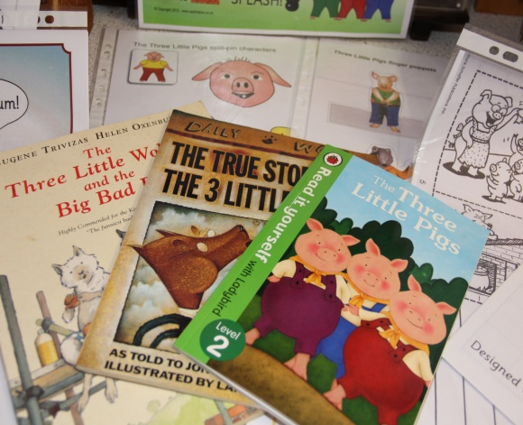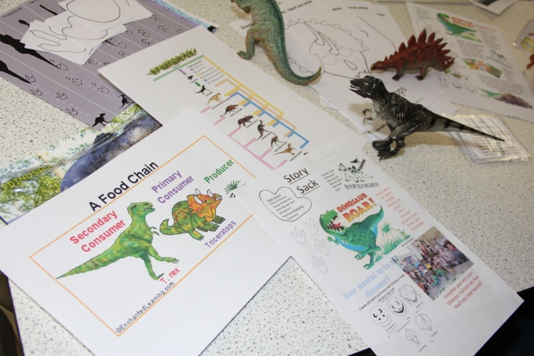

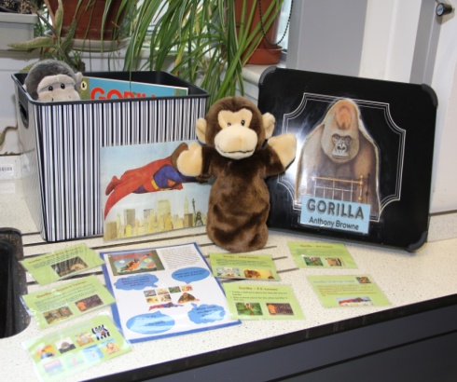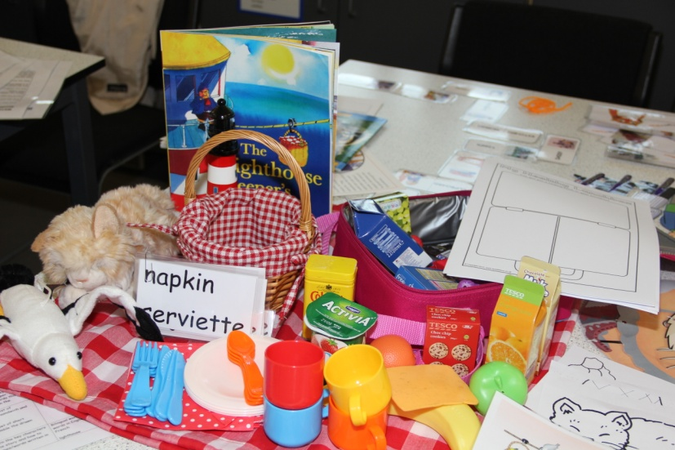

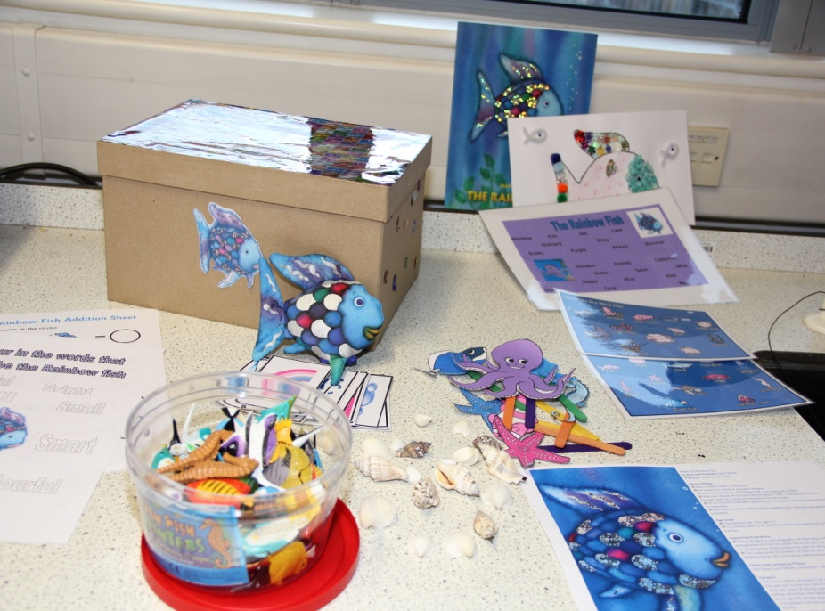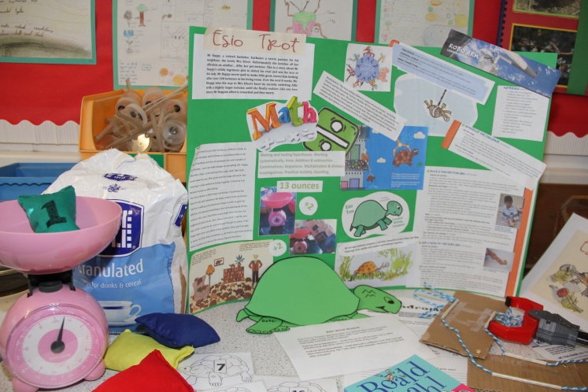

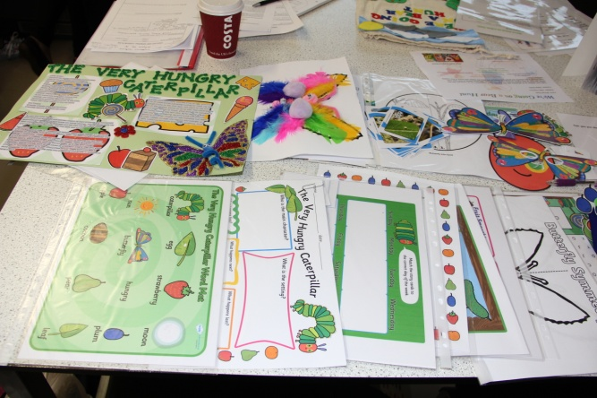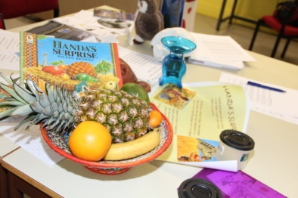

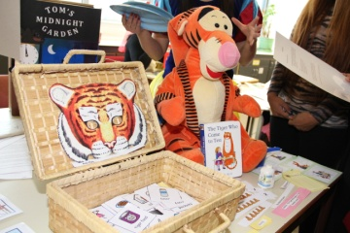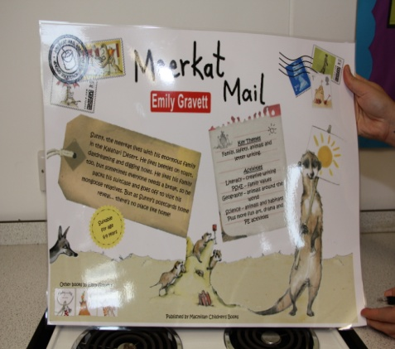

Mathematics Professional Learning Activities

Introduction and context

As part of achieving the Standards for Qualified Teacher Status (QTS), you will need to have a secure and working knowledge of mathematics at your own level (defined as approximately GCSE grade B), as well as knowledge and understanding of how to teach the subject in primary schools. You are also required to pass the National Skills Test in Numeracy before commencing the course (this will have been a condition of your offer if you had not passed it prior to your interview). It is not unusual for PGCE students to find that they need to revise or re-learn some aspects of mathematics at their own level, especially when study for GCSEs is a distant memory! During the PGCE course, we support you in this process of revision through the general mathematics sessions, as well as additional Maths Booster Courses where necessary. We also run a peer mentoring scheme where students with more secure subject knowledge support those with lower confidence levels. However, we also ask you to work on developing this knowledge through personal study. The Haylock book below is an excellent source of support in developing your ideas about mathematics. The tasks below are designed to give you a flying start on all these aspects of PGCE course.

Maths Task 1: Core text

There is one set book for the mathematics element of the course and it is highly recommended that you purchase a copy of this in preparation for the course: Haylock, D (2014) Mathematics Explained for Primary Teachers, Sage Publications Ltd (5th ed)

Maths Task 2: Calculation reflection

The way that mathematics is taught in school has changed considerably over the last few decades. One of our Partnership schools has published their calculation policy on their website (https://fluencycontent-schoolwebsite.netdna-ssl.com/FileCluster/VaughanPrimarySchool/Mainfolder/policies/Vaughan%20Primary%20School%20Calulation%20policy%202014.pdf) so we would like you to read this and write a reflection (approximately 500 words) on how these strategies differ or otherwise, from your own experience of learning mathematics in school. Please bring this with you to your first mathematics session.

PLA Title: | Maths Task 2: Calculation Reflection
Teachers’ Standards Reference(s): (Students to cross reference TSs here for this PLA)
Points for Personal Reflection:
- What surprised you about the calculation policy?
- How does it differ to your own experiences of learning to calculate?
- How are these strategies similar or different to the strategies you currently use to calculate?
- What are your beliefs about learning to calculate and how do you feel about the calculation policy you have read?

Maths Task 3: Subject knowledge audit

Register on the NCETM website - https://www.ncetm.org.uk/. You will find a wealth of extremely useful material here and as part of this task we would like you to complete the self-evaluation tool to audit your confidence in various areas of mathematics. You should click on Mathematics Content Knowledge, then Key Stage 2. We would like you to rate your confidence in each of the areas and then bring a print out of the summary page to your first mathematics session at Brunel which you will submit as part of our auditing process.

Maths Task 4: Subject associations

Explore the Mathematics Association (MA) and Association of Teachers of Mathematics (ATM) websites to identify resources that may be of use during the year.

We look forward to working with you on the Primary PGCE course at Brunel.

Best regards,

The Primary maths team

Science Professional Learning Activity

Science Task 1: Reflection

Please complete a reflection (approx. 500 words) on your thoughts about the purpose and value of science education. We have included some questions that you should address below. Please bring along your reflections to the first science seminar and be prepared to discuss these during the sessions.

PLA Title: | Science Task 1: Reflection
Teachers’ Standards Reference(s): (Students to cross reference TSs here for this PLA)
Points for Personal Reflection

- What is the purpose of science (in primary school)?
- What makes a good teacher of science (in primary school)?
- What science did you see during your pre-course experience and your experience prior to starting the PGCE Primary programme?
- What was it like? How was it the same/different to your own experiences as a primary pupil?
- What excites you about being a teacher of science?
- What concerns do you have about being a teacher of science?

Science Task 2: Subject knowledge

In order to best prepare you for the science element of the programme, we recommend that you engage with the following:

National Curriculum:

National Curriculum for England Science Programmes of Study Key Stage 1 & 2 (2013) Available at: https://www.gov.uk/government/uploads/system/uploads/attachment_data/file/239132/PRIMARY_national_curriculum_-_Science.pdf

Subject knowledge recommended reading:

Farrow, S. (2006) The Really Useful Science Book: A framework of knowledge for Primary Teachers, London, Falmer

We look forward to working with you all on the PGCE Primary Science module at Brunel University London.

PGCE Primary Science team

General Professional Education (GPE)

As part of the GPE programme we will talk to you about techniques to ensure that you are able to create and maintain a positive learning environment for your pupils. The PLAs below have been designed in collaboration with our school partners to provide effective learning opportunities before the course starts.

PLA Title: | GPE Task 1: Creating a positive learning environment
Teachers’ Standards Reference(s): (Students to cross reference TSs here for this PLA)
During your pre-course observations, provide examples of the things teachers do to create a positive learning environment with their pupils:

PLA Title: | GPE Task 2: Classroom layout
Teachers’ Standards Reference(s): (Students to cross reference TSs here for this PLA)
On pre-course visits take note of how different teachers use a variety of classroom layouts to aid behaviour, depending upon what they are teaching and what the children are expected to learn.

