Social Work Action Network (SWAN) Conference 2018
This year’s SWAN national conference titled “Whose side are we on? Social Work, Austerity, Racism and Resistance!” was hosted by the University of Essex in Southend and the biggest conference to date. The conference itself was a 2-day event between the 20th of April to the 21st of April.
The conference allowed a great opportunity to network with fellow social work students, social workers and other professionals and enabled me to get a greater insight into the wider world of social work. There were various workshops throughout the conference allowing those in attendance to further expand their knowledge. One workshop that I found particularly interesting was by Garfield Hunt (University of Suffolk – Social Work lecturer) who discussed his research on the topic of racism and how this affected BAME students experience at university and why they were not identifying themselves with their culture. Garfield went on to highlight that his research found that BAME students focused on what they felt were structural inequalities within the university which they felt put them at a disadvantage to their fellow ethnic white students who made up the majority of the class.
Consequently, the BAME students felt they were being discriminated against and a feeling of isolation was apparent among the BAME students’ experience at university as they said others would make them aware of their difference – for example, in reference to some of the students having an accent. In addition, some of the BAME students felt they were unable to express themselves properly in class discussion or written work because there existed that fear of being judged.
I found this very eye-opening as I come from a Pakistani/Indian background. However, the demographic of my class is quite the opposite and is mainly made up of BAME students and therefore might be the reason why quite honestly there has not been an occasion where my ethnic difference has led to me questioning whether what I say will lead to me being judged and a sense of isolation.
In addition, Dora Teloni a professor at the Technological Educational Institute of Athens gave a lecture on austerity in Greece and what the implications were for refugees. Dora discussed how Europe “welcomes” refugees but their policies end up resulting in refugees feeling repressed and intimidated. I found this lecture very insightful as Dora explained that the current so-called refugee crisis is not something that is new but rather a consequence of foreign policy mainly referring to the recent war in Syria but also in Iraq and Afghanistan. She went on to explain the difficulties that are faced by the refugees on arrival to Greece such as many families having no access to the health care system and children not having any access to state education.
Final Thoughts
Reflecting back on my experience at the conference I feel that this should be an experience for all social work students to attend simply because of the various people and organisations that are present who can offer an insight into the Social Work sphere. This I feel for students would be a priceless experience to be able to hear from experienced professionals from various backgrounds discussing a range of topics relevant to social work but also being able to share an event with people who have a similar passion for making a difference in other people’s lives. I feel attending events such as the SWAN conference to me reinforces the rewarding nature of being a social worker, which at times can be very stressful and underappreciated.

Yousuf Rafiudin, MA Social Work student

Social Work Action Network (SWAN) Conference 2018

Whose Side Are We On? Social Work, Austerity, Racism and Resistance!
20-21 April 2018 - University of Essex

Why join SWAN?

SWAN (Social Work Action Network) is a group of practitioners, students, service users and academics that unite as a radical, campaigning group that aim to challenge the current social work climate, government cuts and austerity. I have been lucky enough to attend both the 2017 conference in Middlesbrough and the 2018 conference in Essex.

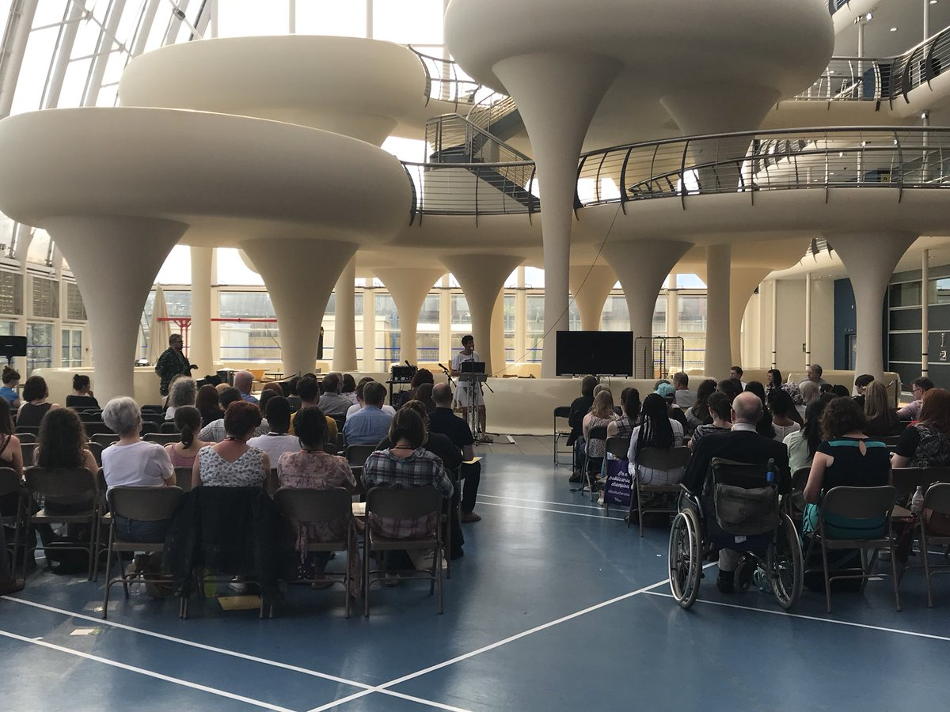

The 2018 conference included talks about Social Rights and Social Justice, Inequality and the crisis in housing and social care, Grenfell Tower, The Crisis in Children and Family Social Work and Racism and the Rise of Right Wing Populism.

The conference also included various workshops that you can chose between, depending on your interests. Choosing is the difficult part. I chose to attend the following:

Anarchism and Social Work – The case for Service User Control by Marie Porter and Mark Baldwin

•Building new kinds of relationships with service users – non-hierarchical, non- coercive
•Stressing critical reflection, particularly in relation to the use of authority. “Is my use of power/authority in this case justified?” It very rarely is. “All exercise of authority perverts, and all submission to authority humiliates.”
•Work towards decentralisation – localised and community focused work is more attuned to the needs of people.
•Working towards service user control of services – relinquishing power at every opportunity
•Pursuing the need to act collectively within our work places
•Working with and building relationships within social movements outside work
•Being disobedient

Relationship based Social Work by Darren Hill

Darren Hill spoke about how the current climate of austerity in our services, especially social work is leading a movement back to relationship based practice as there is little money. He believes that for relationship based practice to work successfully the social worker must see themselves as a resource and valuable tool. He also highlights the importance of time as a tool. Support, time and relationship. This can be linked to models such as social pedagogy. It relies on personal connection and collective alliances.

Social Work for the Lazy Radicals by Jane Fenton

Jane explains how social worker can still be radical without being a social work activist. She explains how you can use your everyday practice to challenge the current social work climate. She explained how too many social workers are “doing the right thing, rather than questioning the right thing to do”. For example, meeting time scales and management expectations rather than what is right for the service user.

She explained that social work should be rooted by the values and should include relationship building, trust and emotional engagement. Critical thinking is an important skill for lazy radicals and should be used beyond supervision. She highlights the importance of courage under dictatorship.

Why I enjoy being part of SWAN

Swan is a great place to make new friends and to build a network of people with similar interests and passion. It is refreshing to hear fellow social workers have a voice, and talk up about what they believe in and what isn’t right about our current services, government and workplaces. It’s like being surrounded by the people you confide in on your lunch break, or when you get home from a bad day.

The conversations are constructive and debates are respectful. However, SWAN is not just about talking about the problem. It’s about joining with others to challenge and make a change. While others may not be as radical as some, SWAN gives you the opportunity to be with compassionate, inclusive and eager social workers. One woman I spoke to at the train station said each year she attends the conference and she feels refreshed, and it re-lights the fire in her belly and the passion she has for the profession that is often dampened in the work place. The said that she returns with a new boost of energy and that as this starts to dwindle again, the next conference comes around.

As a future social worker, I hope to be part of SWAN in the years to come. Next year’s conference will be held in Liverpool, hopefully Brunel will continue to fund students to this event and I hope to see you there.

Sophie Spilsbury – MA2 Social Work

