Powerpoint Presentations

Slides - the good, the bad (and the ugly)

This is a good example of a Powerpoint slide.
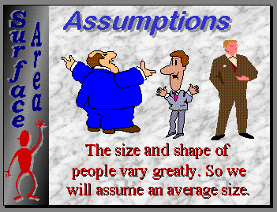

The colours, text used in this slide make it clear to read, it is interesting and there is not too much information to confuse people.

A bad example of a Powerpoint Slide
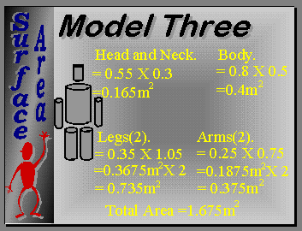

There is a lot of mathematical calculations, these are close together making understanding confusing. The yellow is difficult to read against the background.

