|  |
| --- |
|  |
| **Part 2: Student Equality and Diversity Annual Report 2012/13 (Data)** |
|  |

**Contents**

|  |  |
| --- | --- |
| **Background** | **2** |
| **Student Equality and Diversity Data: Age-on-Entry, Disability, Ethnicity and Gender**  **2008/2009 – 2012/13** | **3** |
| * **Key Highlights: Student Equality and Diversity Data 2008/09 – 2012/13** | **4** |
| * **Key Highlights: Brunel University London and its Comparators 2010/11 – 2012/13** | **6** |
| * **Key Highlights: Brunel University London and the National Picture** | **7** |
| **Brunel University London: Student Equality and Diversity Data**  **Age-on-Entry, Disability, Ethnicity and Gender 2008/2009 – 2012/13** | **8 - 18** |
| **Brunel University London and its Comparators:**  **Student Equality and Diversity Data**  **Age-on-Entry, Disability, Ethnicity and Gender**  **2010/11 - 2012/13** | **19 - 28** |

**Background**

**Overview**

This Report contains the second part of the 2012/13 Student Equality and Diversity Annual Report. The first part of the Report was presented to the Student Equality and Diversity Committee in May 2014. The first part of the Report did not include any student equality and diversity data. However, the Committee was informed at the time that the relevant data would be provided at a later date.

This Report should be read in conjunction with the first part of the Student Equality and Diversity Report 2012/13.

**Data Source**

The data used within this Report covers the following years:

* Brunel University London’s Student Equality and Diversity Data (2008/09 – 2012/13);
* Brunel University London’s Comparators Data (2010/11 – 2012/13);
* National Data (2002/03 – 2011/12).

Unless otherwise stated, the data used within the Report was provided by the University’s Planning Office and was taken from the Higher Education Information Database for Institution (HEIDI) Equality. The Student Equality and Diversity data provided covers the following protected characteristic: ‘Age-on-Entry’, ‘Ethnicity’, ‘Gender’ and ‘Disability’.

The benchmark trend analysis on ‘Age-on-Entry’, ‘Ethnicity’, ‘Gender’ and ‘Disability’ compares the University with a range of 12 comparator universities. The Universities chosen were selected on the basis of being Brunel’s closest comparators as well as aspirational institutions based on Geographical location, Student numbers, Student mix, Research income, A-level tariff, HEFCE teaching grant and Subject mix. As part of the new Strategic Plan the following institutions were identified as comparators to benchmark against. The University of Bath, The City University, The University of Kent, Loughborough University, Queen Mary University of London, The University of Reading, Royal Holloway and Bedford New College, The University of Southampton, The University of Surrey, The University of Sussex and The University of York’)

Data relating to the national picture was taken from the ‘Equality in Higher Education: Statistical Report 2013, Part 2: Students’. The Statistical Report was produced by the Equality Challenge Unit and the data used was provided by the Higher Education Statistics Agency. To access this report please visit, <http://www.ecu.ac.uk/publications/files/equality-in-he-statistical-report-2013-students.pdf/view>

1. **Student Equality and Diversity Data:**

**Age-on-Entry, Disability, Ethnicity and Gender**

**2008/2009 – 2012/13**

**Key Highlights: Student Equality and Diversity Data 2008/09 – 2012/13**

**Total of Students**

- After gaining a significant increase in the number of students studying at the University between 2008/09 and 2009/10 (an increase of over 1000 students), the number of students who studied at the University in the subsequent years until 2012/13 gradually decreased.

- The University’s student population decreased by 2% between 2010/11 and 2011/12. This figure decreased further to 4% between 2011/12 and 2012/13.

- In total 15,314 students studied at Brunel in 2012/13.

**Age-on-Entry**

- Changes to the ‘Age on Entry’ breakdown (within the total student population) in the reporting period was seen in the ‘Under 21’ category and the ‘21 – 24’ category. These groups decreased by 4% and 5% respectively between 2008/09 and 2012/13.

- In that same period, there were no significant increases in the other age groups. There were small increases of 1% and 1.7% within the ‘25-29’ and the ‘30+’ age groups respectively.

**Disability**

- Although when compared to the previous year, the percentage of Brunel’s total student population fell in 2012/13 by about 4%, there was an increase in the number (this number increased by 70) of disabled students at the University.

- When compared to the year before, this figure made up a 0.8% increase in the total student population, but a 5% increase in the disabled student population.

- In fact, Brunel’s disabled student population rose year on year during the reporting period. There was a 7% increase in the disabled student population in 2008/09 when compared to 2009/10, a 9.4% increase in the disabled student population in 2009/10 when compared to 2010/11 and the most significant, a 13% increase in the disabled student population in 2011/12 when compared to 2012/13.

- Since 2010/11 there has been a steady increase in the percentage of postgraduate students who declared a disability. In 2012/13, over 19% of postgraduate students declared a disability.

- In 2012/13, 11% of Brunel’s disabled students said they had a ‘Mental Health Condition’.

- Over the 5 years, ‘Specific Learning Difficulty’ remained the highest declared disability amongst Brunel’s disabled students. In 2012/13, 57% of Brunel’s disabled students had a ‘Specific Learning Difficulty’.

**Ethnicity**

- There has been a significant increase in the percentage of ‘Non UK Domicile’ students studying at the University. There was a substantial increase (just under 4%) between 2008/09 and 2009/10. In fact, over the reporting period (2008/09 – 2012/13) this group increased by a notable 7.6%.

- When looking at the total student population, over the reporting period, the percentage of students who identified as ‘Asian’ or ‘Black’ decreased gradually when compared to students who identified as ‘White’.   
- When looking at the total student population, students who identified as ‘Asian’ or ‘Black’ decreased by about 3% and about 4% between 2008/09 and 2012/13 respectively.

- However, there was a significant increase in the number of ‘Non UK Domicile’ students who studied at the University. Students who identified as ‘Non UK Domicile’ (within the total student population), increased by a significant 7.6% between 2008/09 – 2012/13.

- When looking at ‘UK Domicile’ students only, students who identified as ‘White’ increased by about 4% between 2008/09 and 2012/13.

- When looking at ‘UK Domicile’ students only, ‘Black’ students who studied at the University decreased by about 3.5% between 2008/09 and 2012/13. There was no significant change to the percentage of ‘Asian’ students studying at the University.

**Gender**

- Since 2008/09 there has been a continuous and gradual reduction in the percentage of ‘Female’ students (1.4%) and a continuous and gradual increase in the percentage of ‘Male’ students (1.4%) at the University (when looking at the total student population).

***Please refer to pages 8 – 18 for the data relating to this section.***

**Key Highlights: Brunel University London and its Comparators 2010/11 – 2012/13**

**Age**

- Like most of its comparators, most students at Brunel were aged 24 years and under (2010/11 – 2012/13).

**Disability**

- When compared to its comparators, Brunel had the third highest percentage of disabled students in 2012/13.

- Like most of its comparators (between 2010/11 and 2012/13), Brunel’s disabled student population, when looked at within the total population, grew by about 1% every year in 2010/11, 2011/12 and 2012/13.

**Ethnicity**

- Amongst its comparators in 2012/13, Brunel had the second highest percentage of students who identified as ‘Black and Minority Ethnic’ (32%). City University had the highest (39%) and Queen Mark University had the third highest (31%).

- In the same year, Brunel University had the second highest percentage of ‘Asian’ students (20%) and Queen Mary University had the highest percentage of ‘Asian’ students (26%).

- In 2012/13, 2011/12 and 2010/11 Brunel University had the highest percentage of ‘Black’ students (12%, 13% and 14% respectively).

- When compared to its comparators in 2012/13, the University had the highest percentage (31%) of ‘Non UK Domicile’ students.

**Gender**

- Between 2010/11 and 2012/13 Brunel was one of the only three Universities amongst its comparators to have more ‘Male’ students than ‘Female’ students.

- Loughborough University in 2012/13 had 62% ‘Male’ students and 38% ‘Female’ students. In the same year, the University of Bath, like Brunel University London had 54% ‘Male’ students and 46% ‘Female’ students.

***Please refer to pages 19 - 28 for the data relating to this section.***

**Key Highlights: Brunel University London and the National Picture**

Please note that the data used in this section was taken from the ***‘Equality in Higher Education: Statistical Report 2013, Part 2: Students’.*** The document was written and produced by the Equality Challenge Unit and the data used was provided by the Higher Education Statistics Agency. To access this report please visit, <http://www.ecu.ac.uk/publications/files/equality-in-he-statistical-report-2013-students.pdf/view>

**Age**

- Between 2002/03 and 2011/12 (national level), the proportion of students in the ‘21 and under’ and ‘22–25’ age groups increased, while the ‘26–35’ and ’36 and over’ age groups decreased.

- At Brunel, the proportion of students who are ‘25 and under’ although initially decreased in 2008/09, increased steadily between 2009/2010 and 2012/13. In 2012/13, 72.5% of Brunel’s students were aged ‘25 and Under’.

**Disability**

- The proportion of disabled students who declared a ‘Mental Health Condition’ increased from 5.9% in 2007/08 to 9.6% in 2011/12. The percentage of students (9.5%) who declared a ‘Mental Health Condition’ at Brunel in 2011/12 was similar to the national figure.

**Gender**

- Between 2002/03 and 2011/12 (national level), there were consistently more ‘Female’ students than ‘Male’ students. While the proportion of ‘Male’ students gradually increased from 42.7% in 2003/04 to 43.6% in 2011/12, there remained a difference of 12.8% between ‘Male’ and ‘Female’ representation.

- Contrary to the national picture, Brunel has traditionally always had more ‘Male’ students than ‘Female’ students.

- In 2012/13 there was a 7% difference in the percentages of ‘Male’ and ‘Female’ students who studied at the University.

1. **Brunel University London: Student Equality and Diversity Data**

**Age-on-Entry, Disability, Ethnicity and Gender 2008/2009 – 2012/13**

**Age on entry**

**Chart 1: Age-on-Entry (Total Student Population) 2008/09 - 2012/13**

|  |  |  |  |  |  |  |  |  |  |
| --- | --- | --- | --- | --- | --- | --- | --- | --- | --- |
| **2008/13 Brunel University London Age Distribution** | **Under 21** | | **21-24** | | **25-29** | | **30+** | | **Total** |
| No. | % | No. | % | No. | % | No. | % |  |
| **2008/2009** | 6,840 | 45.36 | 3,995 | 26.49 | 1,835 | 12.17 | 2,410 | 15.98 | 15,080 |
| **2009/2010** | 6,920 | 42.22 | 4,625 | 28.22 | 2,280 | 13.91 | 2,565 | 15.65 | 16,390 |
| **2010/2011** | 6,745 | 41.60 | 4,785 | 29.51 | 2,265 | 13.97 | 2,420 | 14.92 | 16,215 |
| **2011/2012** | 6,665 | 41.98 | 4,735 | 29.83 | 2,105 | 13.26 | 2,370 | 14.93 | 15,875 |
| **2012/2013** | 6,295 | 41.13 | 4,805 | 31.39 | 2,015 | 13.17 | 2,190 | 14.31 | 15,305 |

**Table1:** **Age-on-Entry (Total Student Population) 2008/09 - 2012/13**

**Disability**

**Chart 2: Disability (Total Student Population) 2008/09 - 2012/13**

|  |  |  |  |  |  |  |  |
| --- | --- | --- | --- | --- | --- | --- | --- |
| **2008/13 Disability Population** | **Known to be Disabled** | | **No Known Disability** | | **Disability Not Known/Sought** | | **Total** |
| No. | % | No. | % | No. | % |  |
| **2008/2009** | 985 | 6.53 | 13,965 | 92.54 | 140 | 0.93 | 15,090 |
| **2009/2010** | 1,060 | 6.92 | 14,185 | 92.56 | 80 | 0.52 | 15,325 |
| **2010/2011** | 1,170 | 7.22 | 14,980 | 92.38 | 65 | 0.40 | 16,215 |
| **2011/2012** | 1,345 | 8.47 | 14,510 | 91.34 | 30 | 0.19 | 15,885 |
| **2012/2013** | 1,415 | 9.24 | 13,890 | 90.67 | 15 | 0.10 | 15,320 |

**Table 2:** **Disability (Total Student Population) 2008/09 - 2012/13**

**Disability Type**

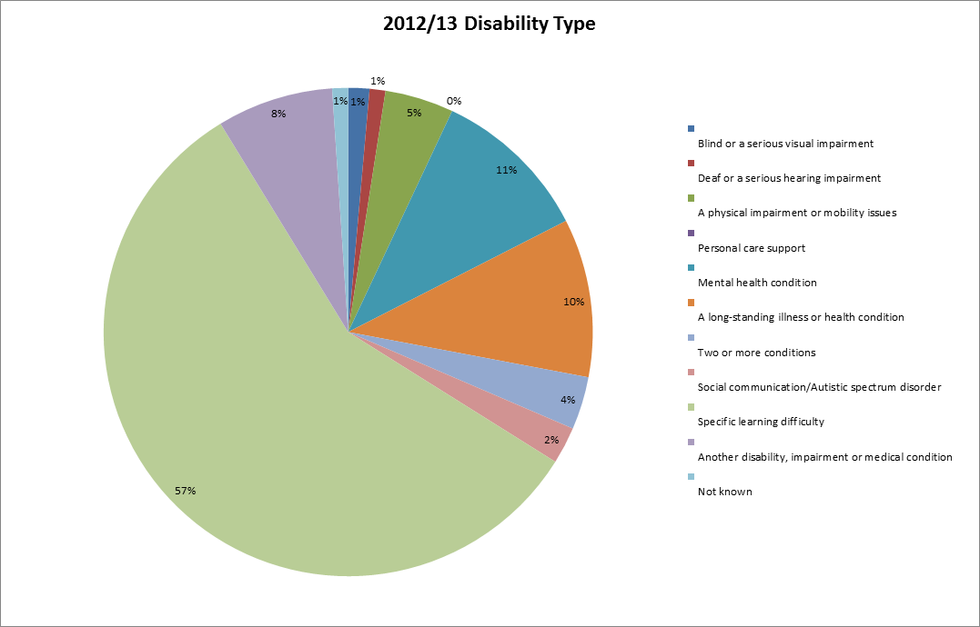

**Chart 2a: Disability Types 2012/13 (Disabled Student Population)**

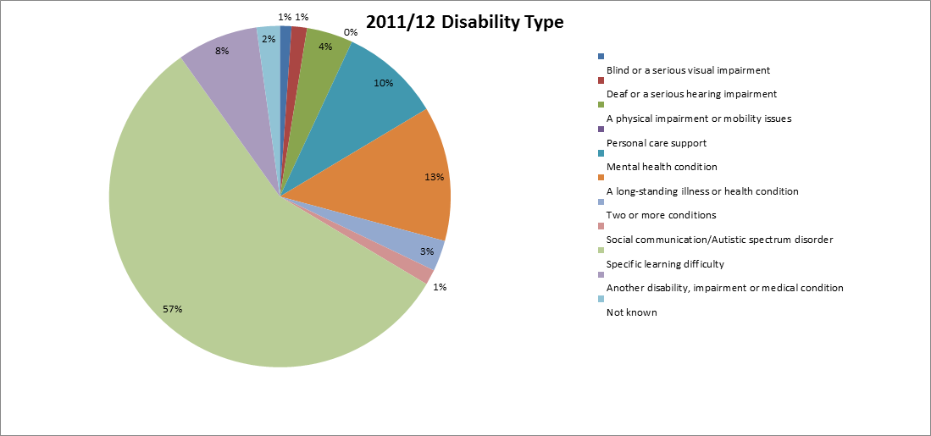

**Chart 2b: Disability Types 2011/12 (Disabled Student Population)**

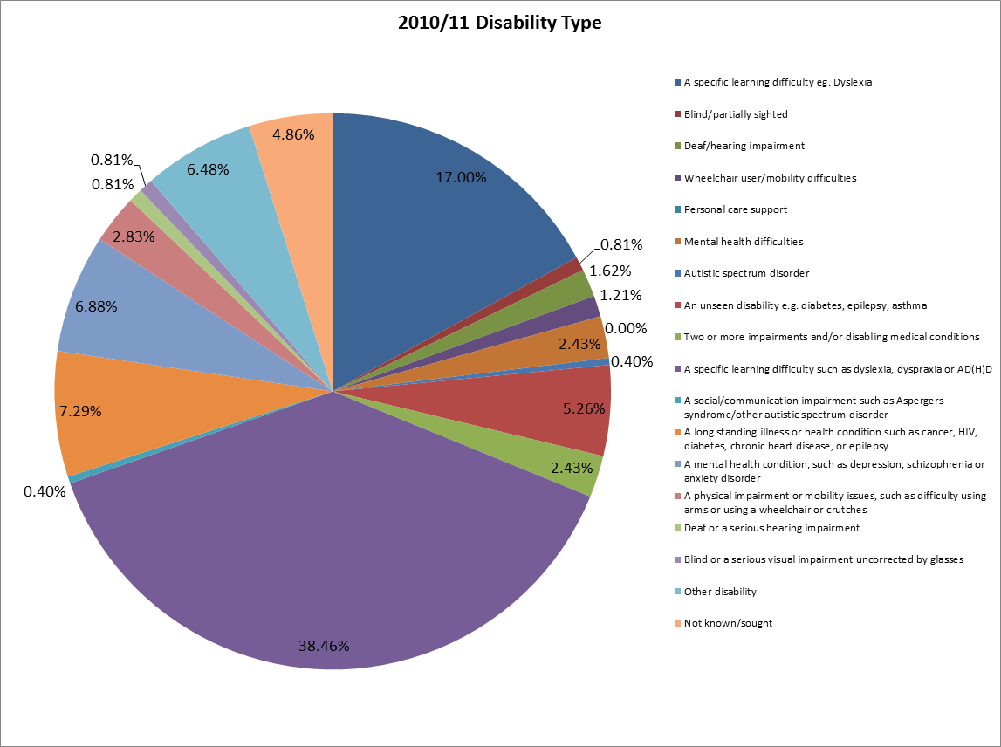

**Chart 2c: Disability Types 2010/11 (Disabled Student Population)**

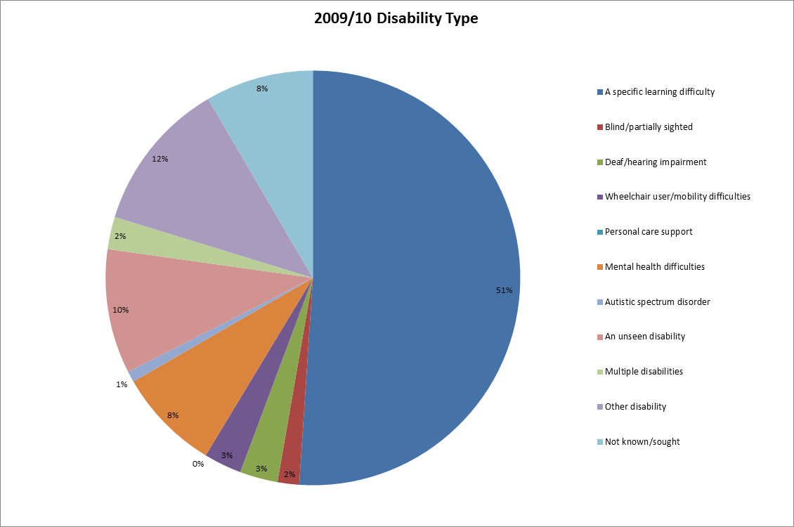

**Chart 2d: Disability Types 2009/10 (Disabled Student Population)**

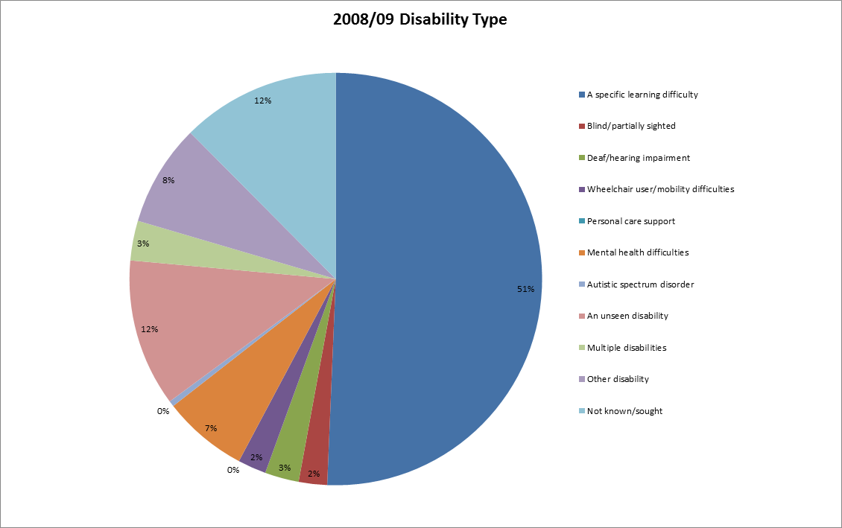

**Chart 2e: Disability Types 2008/09 (Disabled Student Population)**

**Ethnicity**

**Chart 3:** **Ethnicity (Total Student Population) 2008/09 - 2012/13**

|  |  |  |  |  |  |  |  |  |  |  |  |  |  |  |
| --- | --- | --- | --- | --- | --- | --- | --- | --- | --- | --- | --- | --- | --- | --- |
| **Ethnicity** | **White** | | **Black** | | **Asian** | | **Other (Including Mixed)** | | **Not Known** | | **Non UK Domicile** | | **Total** | |
|  | No. | % | No. | % | No. | % | No. | % | No. | % | No. | % |  |
| **2012/2013** | 4,595 | 30.00 | 1,835 | 11.98 | 3,025 | 19.75 | 1,010 | 6.59 | 115 | 0.75 | 4,735 | 30.92 | 15,315 |
| **2011/2012** | 4,760 | 29.97 | 2,100 | 13.22 | 3,250 | 20.46 | 1,055 | 6.64 | 140 | 0.88 | 4,580 | 28.83 | 15,885 |
| **2010/2011** | 4,620 | 28.49 | 2,235 | 13.78 | 3,445 | 21.25 | 1,050 | 6.48 | 160 | 0.99 | 4,705 | 29.02 | 16,215 |
| **2009/2010** | 4,750 | 28.96 | 2,400 | 14.63 | 3,560 | 21.71 | 1,060 | 6.46 | 175 | 1.07 | 4,455 | 27.16 | 16,400 |
| **2008/2009** | 4,525 | 30.00 | 2,395 | 15.88 | 3,410 | 22.61 | 1,050 | 6.96 | 190 | 1.26 | 3,515 | 23.30 | 15,085 |

**Table 3: Ethnicity (Total Student Population) 2008/09 - 2012/13**

**Gender**

**Chart 4: Gender (Total Student Population) 2008/09 - 2012/13**

|  |  |  |  |  |  |
| --- | --- | --- | --- | --- | --- |
| **Gender** | **Female** | | **Male** | | **Total** |
| No. | % | No. | % |  |
| **2012/2013** | 7,110 | 46.44 | 8,200 | 53.56 | 15,310 |
| **2011/2012** | 7,415 | 46.69 | 8,465 | 53.31 | 15,880 |
| **2010/2011** | 7,495 | 46.22 | 8,720 | 53.78 | 16,215 |
| **2009/2010** | 7,760 | 47.29 | 8,650 | 52.71 | 16,410 |
| **2008/2009** | 7,225 | 47.88 | 7,865 | 52.12 | 15,090 |

**Table 4:** **Gender (Total Student Population) 2008/09 - 2012/13**

1. **Brunel University London and its Comparators:**

**Student Equality and Diversity Data**

**Age-on-Entry, Disability, Ethnicity and Gender**

**2010/11 - 2012/13**

*‘The data in the following section provides benchmark trend analysis on ‘Age-on-Entry’, ‘Ethnicity’, ‘Gender’ and ‘Disability’ for a range of 12 comparator universities. The Universities chosen were selected on the basis of being Brunel’s closest comparators as well as aspirational institutions based on Geographical location, Student numbers, Student mix, Research income, A-level tariff, HEFCE teaching grant and Subject mix. As part of the new Strategic Plan the following institutions were identified as comparators to benchmark against. The University of Bath, The City University, The University of Kent, Loughborough University, Queen Mary University of London, The University of Reading, Royal Holloway and Bedford New College, The University of Southampton, The University of Surrey, The University of Sussex and The University of York’).*

**Age-on-Entry**

|  |  |  |  |  |  |  |  |  |  |  |  |  |
| --- | --- | --- | --- | --- | --- | --- | --- | --- | --- | --- | --- | --- |
| **Age #** | **2012/13 Under 21** | **2012/13 21 - 24** | **2012/13 25 - 29** | **2012/13 30 and over** | **2011/12 Under 21** | **2011/12 21 - 24** | **2011/12 25 - 29** | **2011/12 30 and over** | **2010/11 Under 21** | **2010/11 21 - 24** | **2010/11 25 - 29** | **2010/11 30 and over** |
| The University of Bath | 6885 | 4565 | 1195 | 2,410 | 6755 | 4390 | 1,165 | 2825 | 6565 | 4125 | 1335 | 3,280 |
| Brunel University London | 6,305 | 4,805 | 2,015 | 2,190 | 6,670 | 4,735 | 2,110 | 2,370 | 6,750 | 4,785 | 2,265 | 2,420 |
| The City University | 4,695 | 4,940 | 2,805 | 4,080 | 4,555 | 6,180 | 3,615 | 4,985 | 4,235 | 5,205 | 3,185 | 4,875 |
| The University of Kent | 10,835 | 5,455 | 1,545 | 1,980 | 11,180 | 5,220 | 1,625 | 2,285 | 10,300 | 4,575 | 1,585 | 2,490 |
| Loughborough University | 7,965 | 4,885 | 1,010 | 1,600 | 8,205 | 5,045 | 1,040 | 1,735 | 8,425 | 4,775 | 1,080 | 1,845 |
| Queen Mary University of London | 6,840 | 5,020 | 1,835 | 1,350 | 6,950 | 4,785 | 1,725 | 1,400 | 6,800 | 4,665 | 1,835 | 1,525 |
| The University of Reading | 6,685 | 3,220 | 1,105 | 2,430 | 6,620 | 3,205 | 1,160 | 2,520 | 6,290 | 3,200 | 1,215 | 2,490 |
| Royal Holloway and Bedford New College | 4,925 | 2,660 | 865 | 1,105 | 4,935 | 3,150 | 795 | 980 | 5,035 | 2,570 | 800 | 1,110 |
| The University of Southampton | 10,365 | 6780 | 2585 | 3385 | 10640 | 7085 | 2610 | 3795 | 10455 | 6690 | 2555 | 3610 |
| The University of Surrey | 5,285 | 4,305 | 1,515 | 2,795 | 5,770 | 4,595 | 1,650 | 3,040 | 5,655 | 4,920 | 2,300 | 3,385 |
| The University of Sussex | 6,415 | 4,005 | 1,315 | 1,405 | 6,200 | 3,930 | 1,375 | 1,620 | 5,615 | 3,425 | 1,275 | 1,910 |
| The University of York | 8360 | 4425 | 1390 | 1975 | 8360 | 5025 | 1720 | 2300 | 7880 | 4645 | 1630 | 2525 |

**Table 5a: Age-on-Entry (#) Brunel University London and its Comparators 2010/11 -2012/13**

|  |  |  |  |  |  |  |  |  |  |  |  |  |
| --- | --- | --- | --- | --- | --- | --- | --- | --- | --- | --- | --- | --- |
| **Age %** | **2012/13 Under 21** | **2012/13 21 - 24** | **2012/13 25 - 29** | **2012/13 30 and over** | **2011/12 Under 21** | **2011/12 21 - 24** | **2011/12 25 - 29** | **2011/12 30 and over** | **2010/11 Under 21** | **2010/11 21 - 24** | **2010/11 25 - 29** | **2010/11 30 and over** |
| The University of Bath | 46% | 30% | 8% | 16% | 45% | 29% | 8% | 19% | 43% | 27% | 9% | 21% |
| Brunel University London | 41% | 31% | 13% | 14% | 42% | 30% | 13% | 15% | 42% | 30% | 14% | 15% |
| The City University | 28% | 30% | 17% | 25% | 24% | 32% | 19% | 26% | 24% | 30% | 18% | 28% |
| The University of Kent | 55% | 28% | 8% | 10% | 55% | 26% | 8% | 11% | 54% | 24% | 8% | 13% |
| Loughborough University | 52% | 32% | 7% | 10% | 51% | 31% | 6% | 11% | 52% | 30% | 7% | 11% |
| Queen Mary University of London | 45% | 33% | 12% | 9% | 47% | 32% | 12% | 9% | 46% | 31% | 12% | 10% |
| The University of Reading | 50% | 24% | 8% | 18% | 49% | 24% | 9% | 19% | 48% | 24% | 9% | 19% |
| Royal Holloway and Bedford New College | 45% | 29% | 11% | 15% | 50% | 32% | 8% | 10% | 53% | 27% | 8% | 12% |
| The University of Southampton | 52% | 27% | 9% | 12% | 44% | 29% | 11% | 16% | 45% | 29% | 11% | 15% |
| The University of Surrey | 38% | 31% | 11% | 20% | 38% | 31% | 11% | 20% | 35% | 30% | 14% | 21% |
| The University of Sussex | 49% | 30% | 10% | 11% | 47% | 30% | 10% | 12% | 46% | 28% | 10% | 16% |
| The University of York | 52% | 27% | 9% | 12% | 48% | 29% | 10% | 13% | 47% | 28% | 10% | 15% |

**Table 5b: Age-on-Entry (%) Brunel University London and its Comparators 2010/11 -2012/13**

**Disability**

|  |  |  |  |  |  |  |  |  |  |
| --- | --- | --- | --- | --- | --- | --- | --- | --- | --- |
| Disabilities # | **2012/13 Known to be disabled** | **2012/13 No known disability** | **2012/13 Not known/sought** | **2011/12 Known to be disabled** | **2011/12 No known disability** | **2011/12 Not known/sought** | **2010/11 Known to be disabled** | **2010/11 No known disability** | **2010/11 Not known/sought** |
| The University of Bath | 910 | 14150 | 0 | 850 | 14,285 | 0 | 770 | 14550 | 0 |
| Brunel University London | 1,410 | 13,885 | 15 | 1,345 | 14,510 | 30 | 1,170 | 14,985 | 60 |
| The City University | 810 | 15,670 | 35 | 885 | 18,340 | 115 | 740 | 16,505 | 255 |
| The University of Kent | 2,090 | 17,725 | 0 | 1,900 | 18,415 | 0 | 1,675 | 17,275 | 0 |
| Loughborough University | 1,750 | 13,695 | 20 | 1,620 | 14,370 | 35 | 1,545 | 14,520 | 50 |
| Queen Mary University of London | 1,185 | 13,860 | 0 | 1,075 | 13,785 | 0 | 940 | 13,865 | 10 |
| The University of Reading | 1,275 | 12,160 | 0 | 1,230 | 12,280 | 0 | 1,145 | 12,050 | 0 |
| Royal Holloway & Bedford New College | 750 | 8,815 | 0 | 735 | 9,130 | 5 | 770 | 8,735 | 15 |
| The University of Southampton | 2,120 | 20995 | 0 | 2,085 | 22045 | 0 | 1870 | 21445 | 0 |
| The University of Surrey | 955 | 12,940 | 0 | 960 | 14,080 | 15 | 950 | 15,270 | 50 |
| The University of Sussex | 1,405 | 11,740 | 0 | 1,400 | 11,730 | 0 | 1,355 | 10,875 | 0 |
| The University of York | 1,575 | 14575 | 0 | 1580 | 15805 | 25 | 1,390 | 15220 | 65 |
|  |  |  |  |  |  |  |  |  |  |

**Table 6a: Disability (#) Brunel University London and its Comparators 2010/11 -2012/13:**

|  |  |  |  |  |  |  |  |  |  |
| --- | --- | --- | --- | --- | --- | --- | --- | --- | --- |
| **Disability %** | **2012/13 Known to be disabled** | **2012/13 No known disability** | **2012/13 Not known/sought** | **2011/12 Known to be disabled** | **2011/12 No known disability** | **2011/12 Not known/sought** | **2010/11 Known to be disabled** | **2010/11 No known disability** | **2010/11 Not known/sought** |
| The University of Bath | 6% | 94% | 0% | 6% | 94% | 0% | 5% | 95% | 0% |
| Brunel University London | 9% | 91% | 0% | 8% | 91% | 0% | 7% | 92% | 0% |
| The City University | 5% | 95% | 0% | 5% | 95% | 1% | 4% | 94% | 1% |
| The University of Hull | 11% | 89% | 0% | 10% | 90% | 0% | 10% | 90% | 0% |
| The University of Kent | 11% | 89% | 0% | 9% | 91% | 0% | 9% | 91% | 0% |
| Loughborough University | 11% | 89% | 0% | 10% | 90% | 0% | 10% | 90% | 0% |
| Queen Mary University of London | 8% | 92% | 0% | 7% | 93% | 0% | 6% | 94% | 0% |
| The University of Reading | 9% | 91% | 0% | 9% | 91% | 0% | 9% | 91% | 0% |
| Royal Holloway & Bedford New College | 8% | 92% | 0% | 7% | 93% | 0% | 8% | 92% | 0% |
| The University of Southampton | 9% | 91% | 0% | 9% | 91% | 0% | 8% | 92% | 0% |
| The University of Surrey | 7% | 93% | 0% | 6% | 94% | 0% | 6% | 94% | 0% |
| The University of Sussex | 11% | 89% | 0% | 11% | 89% | 0% | 11% | 89% | 0% |
| The University of York | 10% | 90% | 0% | 9% | 91% | 0.1% | 8% | 91% | 0.4% |
|  |  |  |  |  |  |  |  |  |  |

**Table 6b: Disability (%) Brunel University London and its Comparators 2010/11 -2012/13**

**Ethnicity**

|  |  |  |  |  |  |  |  |  |  |  |  |  |  |  |  |  |  |  |
| --- | --- | --- | --- | --- | --- | --- | --- | --- | --- | --- | --- | --- | --- | --- | --- | --- | --- | --- |
| **Ethnicity #** | **2012/13 White** | **2012/13 Black** | **2012/13 Asian** | **2012/13 Other (including mixed)** | **2012/13 Not known** | **2012/13 Non-UK domicile** | **2011/12 White** | **2011/12 Black** | **2011/12 Asian** | **2011/12 Other (including mixed)** | **2011/12 Not known** | **2011/12 Non-UK domicile** | **2010/11 White** | **2010/11 Black** | **2010/11 Asian** | **2010/11 Other (including mixed)** | **2010/11 Not known** | **2010/11 Non-UK domicile** |
| The University of Bath | 8,965 | 175 | 695 | 515 | 125 | 4,585 | 9,205 | 190 | 730 | 395 | 205 | 4,410 | 9,385 | 180 | 610 | 375 | 320 | 4,450 |
| Brunel University London | 4,595 | 1,835 | 3,025 | 1,010 | 115 | 4,735 | 4,760 | 2,100 | 3,250 | 1,055 | 140 | 4,580 | 4,620 | 2,235 | 3,445 | 1,050 | 160 | 4,705 |
| The City University | 4,695 | 1,570 | 3,120 | 750 | 180 | 6,210 | 5,370 | 1,895 | 3,455 | 815 | 290 | 7,510 | 5,045 | 2,010 | 3,335 | 740 | 415 | 5,955 |
| The University of Kent | 10,845 | 1,545 | 1,910 | 830 | 155 | 4,525 | 11,520 | 1,470 | 1,635 | 810 | 370 | 4,505 | 11,345 | 1,385 | 1,540 | 715 | 360 | 3,600 |
| Loughborough University | 10,285 | 500 | 1,010 | 440 | 45 | 3,180 | 10,625 | 490 | 1,070 | 435 | 65 | 3,340 | 10,720 | 495 | 1,135 | 425 | 80 | 3,265 |
| Queen Mary University of London | 4,630 | 780 | 3,860 | 1,050 | 120 | 4,600 | 4,715 | 805 | 3,960 | 1,000 | 165 | 4,220 | 4,395 | 885 | 4,170 | 1,015 | 325 | 4,035 |
| The University of Reading | 8,360 | 335 | 855 | 405 | 250 | 3,225 | 8,670 | 305 | 805 | 400 | 220 | 3,100 | 8,630 | 315 | 825 | 370 | 225 | 2,830 |
| Royal Holloway and Bedford New College | 4,610 | 495 | 1,000 | 480 | 125 | 2,855 | 4,615 | 450 | 1,035 | 475 | 165 | 3,125 | 4,570 | 450 | 990 | 465 | 190 | 2,850 |
| The University of Southampton | 14,400 | 495 | 1025 | 710 | 260 | 6,230 | 15,695 | 480 | 980 | 715 | 310 | 5,950 | 15,605 | 435 | 955 | 625 | 330 | 5,360 |
| The University of Surrey | 7,135 | 720 | 1,055 | 485 | 320 | 4,180 | 7,445 | 770 | 1,140 | 490 | 610 | 4,605 | 7,895 | 805 | 1,200 | 505 | 615 | 5,245 |
| The University of Sussex | 7,630 | 345 | 495 | 610 | 100 | 3,965 | 7,985 | 340 | 440 | 625 | 120 | 3,625 | 8,120 | 295 | 350 | 555 | 135 | 2,780 |
| The University of York | 11,215 | 225 | 530 | 415 | 140 | 3,625 | 11,710 | 220 | 620 | 425 | 185 | 4,250 | 11,370 | 200 | 610 | 365 | 260 | 3,875 |

**Table 7a: Ethnicity (#) Brunel University London and its Comparators 2010/11 -2012/13:**

|  |  |  |  |  |  |  |  |  |  |  |  |  |  |  |  |  |  |  |
| --- | --- | --- | --- | --- | --- | --- | --- | --- | --- | --- | --- | --- | --- | --- | --- | --- | --- | --- |
| **Ethnicity %** | **2012/13 White** | **2012/13 Black** | **2012/13 Asian** | **2012/13 Other (including mixed)** | **2012/13 Not known** | **2012/13 Non-UK domicile** | **2011/12 White** | **2011/12 Black** | **2011/12 Asian** | **2011/12 Other (including mixed)** | **2011/12 Not known** | **2011/12 Non-UK domicile** | **2010/11 White** | **2010/11 Black** | **2010/11 Asian** | **2010/11 Other (including mixed)** | **2010/11 Not known** | **2010/11 Non-UK domicile** |
| The University of Bath | 60% | 1% | 5% | 3% | 1% | 30% | 61% | 1% | 5% | 3% | 1% | 29% | 61% | 1% | 4% | 2% | 2% | 29% |
| Brunel University London | 30% | 12% | 20% | 7% | 1% | 31% | 30% | 13% | 20% | 7% | 1% | 29% | 28% | 14% | 21% | 6% | 1% | 29% |
| The City University | 28% | 10% | 19% | 5% | 1% | 38% | 28% | 10% | 18% | 4% | 1% | 39% | 29% | 11% | 19% | 4% | 2% | 34% |
| The University of Kent | 55% | 8% | 10% | 4% | 1% | 23% | 57% | 7% | 8% | 4% | 2% | 22% | 60% | 7% | 8% | 4% | 2% | 19% |
| Loughborough University | 67% | 3% | 7% | 3% | 0% | 21% | 66% | 3% | 7% | 3% | 0% | 21% | 67% | 3% | 7% | 3% | 0% | 20% |
| Queen Mary University of London | 31% | 5% | 26% | 7% | 1% | 31% | 32% | 5% | 27% | 7% | 1% | 28% | 30% | 6% | 28% | 7% | 2% | 27% |
| The University of Reading | 62% | 2% | 6% | 3% | 2% | 24% | 64% | 2% | 6% | 3% | 2% | 23% | 65% | 2% | 6% | 3% | 2% | 21% |
| Royal Holloway and Bedford New College | 48% | 5% | 10% | 5% | 1% | 30% | 47% | 5% | 10% | 5% | 2% | 32% | 48% | 5% | 10% | 5% | 2% | 30% |
| The University of Southampton | 67% | 2% | 4% | 3% | 1% | 23% | 65% | 2% | 4% | 3% | 1% | 25% | 67% | 2% | 4% | 3% | 1% | 23% |
| The University of Surrey | 51% | 5% | 8% | 3% | 2% | 30% | 49% | 5% | 8% | 3% | 4% | 31% | 49% | 5% | 7% | 3% | 4% | 32% |
| The University of Sussex | 58% | 3% | 4% | 5% | 1% | 30% | 61% | 3% | 3% | 5% | 1% | 28% | 66% | 2% | 3% | 5% | 1% | 23% |
| The University of York | 68% | 1% | 4% | 2% | 2% | 23% | 67% | 1% | 4% | 2% | 1% | 24% | 68% | 1% | 4% | 2% | 2% | 23% |

**Table 7b: Ethnicity (%) Brunel University London and its Comparators 2010/11 -2012/13**

**Gender**

|  |  |  |  |  |  |  |
| --- | --- | --- | --- | --- | --- | --- |
| **Gender #** | **2012/13 Female** | **2012/13 Male** | **2011/12 Female** | **2011/12 Male** | **2010/11 Female** | **2010/11 Male** |
| The University of Bath | 6,985 | 8,075 | 7,025 | 8,110 | 7,125 | 8,195 |
| Brunel University London | 5,846 | 6,768 | 6,351 | 7,211 | 6,270 | 7,307 |
| The City University | 7,158 | 5,895 | 7,651 | 5,849 | 7,191 | 5,545 |
| The University of Kent | 9,334 | 8,305 | 9,321 | 8,507 | 8,787 | 7,917 |
| Loughborough University | 5,334 | 8,617 | 5,534 | 8,780 | 5,580 | 9,002 |
| Queen Mary University of London | 7,396 | 6,862 | 7,396 | 6,760 | 7,381 | 6,859 |
| The University of Reading | 6,653 | 5,397 | 6,477 | 5,497 | 6,183 | 5,397 |
| Royal Holloway & Bedford New College | 4,983 | 3,763 | 5,215 | 3,869 | 4,986 | 3,644 |
| The University of Southampton | 12,510 | 16,605 | 13,035 | 11,100 | 12,695 | 10,620 |
| The University of Surrey | 6,687 | 5,373 | 7,242 | 5,861 | 6,994 | 5,702 |
| The University of Sussex | 6,736 | 5,644 | 6,779 | 5,719 | 6,193 | 5,106 |
| The University of York | 9,085 | 7,065 | 9,845 | 7,560 | 9,395 | 7,280 |
|  |  |  |  |  |  |  |

**Table 8a: Gender (#) Brunel University London and its Comparators 2010/11 -2012/13:**

|  |  |  |  |  |  |  |
| --- | --- | --- | --- | --- | --- | --- |
| **Gender %** | **2012/13 Female** | **2012/13 Male** | **2011/12 Female** | **2011/12 Male** | **2010/11 Female** | **2010/11 Male** |
| The University of Bath | 46% | 54% | 46% | 54% | 47% | 53% |
| Brunel University London | 46% | 54% | 47% | 53% | 46% | 54% |
| The City University | 55% | 45% | 57% | 43% | 56% | 44% |
| The University of Hull | 52% | 48% | 53% | 47% | 52% | 48% |
| The University of Kent | 53% | 47% | 52% | 48% | 53% | 47% |
| Loughborough University | 38% | 62% | 39% | 61% | 38% | 62% |
| Queen Mary University of London | 52% | 48% | 52% | 48% | 52% | 48% |
| The University of Reading | 55% | 45% | 54% | 46% | 53% | 47% |
| Royal Holloway & Bedford New College | 57% | 43% | 57% | 43% | 58% | 42% |
| The University of Southampton | 54% | 46% | 54% | 46% | 54% | 46% |
| The University of Surrey | 55% | 45% | 55% | 45% | 55% | 45% |
| The University of Sussex | 54% | 46% | 54% | 46% | 55% | 45% |
| The University of York | 56% | 44% | 57% | 43% | 56% | 44% |

**Table 8b: Gender (%) Brunel University London and its Comparators 2010/11 -2012/13:**