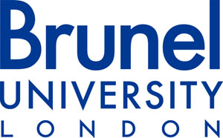

University Research Ethics Committee

RESEARCH ETHICS RISK ASSESSMENT AND MANAGEMENT

This form should be used to support the assessment of risks associated with your research project and their mitigation. This must be completed and submitted where relevant (see questions 43.2 and 44.1 on the Application Form for Research Ethics Approval).

Prior to completion, if there is any aspect of the risks or risk management process associated with your proposed research that you feel unsure about then it is your responsibility (as the researcher) to seek further guidance.

For Completion by the Researcher:

Identified Risks | Likelihood | Potential Impact/Outcome | Risk Management/Mitigating Factors
Identify the risks/hazards present | High/Medium/Low | Who might be harmed and how? | Evaluate the risks and decide on the precautions, e.g., Health & Safety

