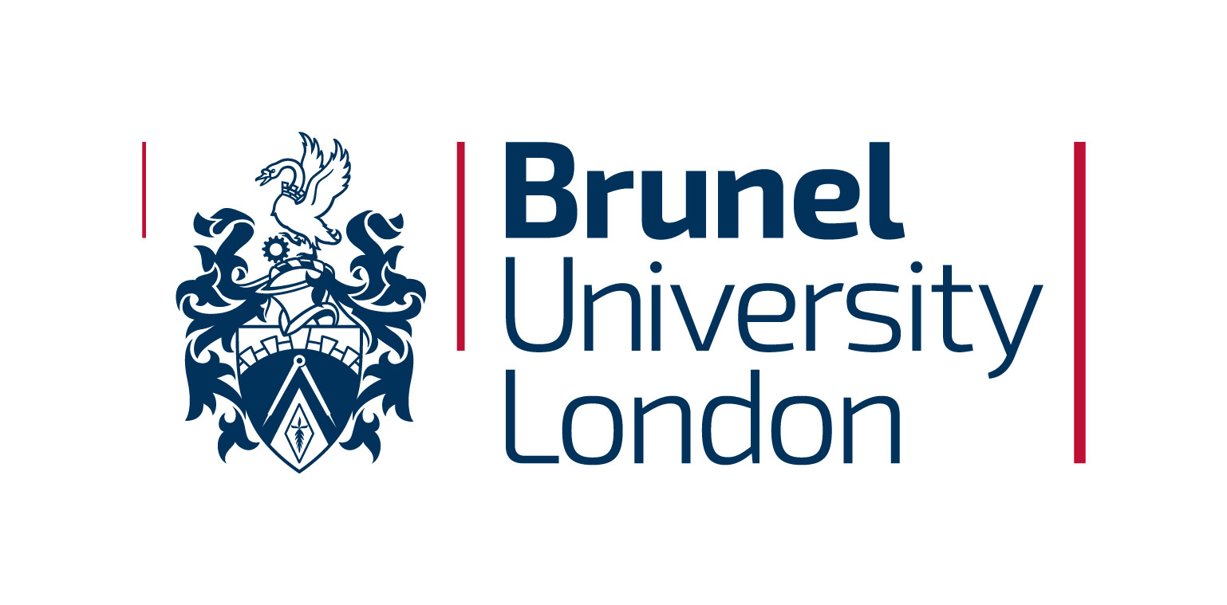

PROGRAMME APPROVAL - DESIGN ENDORSEMENT FORM

Where collaborative cross-department or cross-college programmes are proposed, the endorsement of the relevant Head/s of Department is a requirement of a Design Review Panel.
The purpose of this form is to ensure that the design of a programme that involves cross-department or cross-college collaboration has been reviewed and has the endorsement of the relevant Head of Department, prior to an Initial Design Review or Fast-track Design Review meeting.

This form is the responsibility of the Programme Design Team Leader and should be submitted to the Panel at the final design review meeting.

Lead College

Design Team Leader; contact details

Lead Department:
Design Endorsed by Head of Department
Name:
Signature:
Date:

Contributing Department:

Design Endorsed by Head of Department
Name:
Signature:
Date:

