#InterFaithWeek

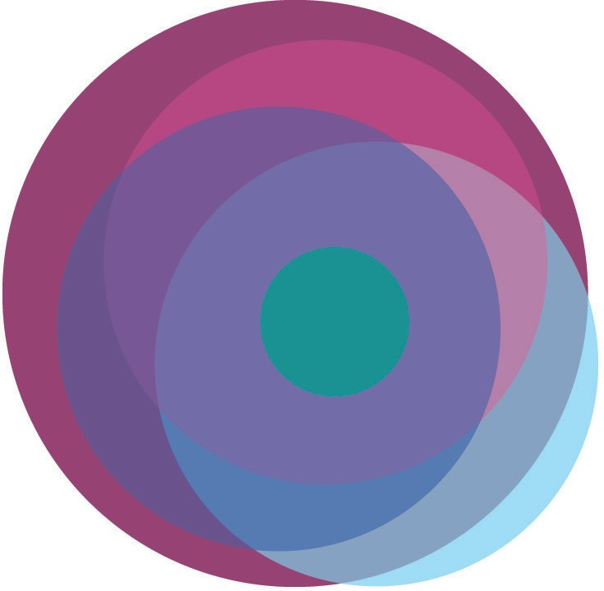
@IFWeek

