
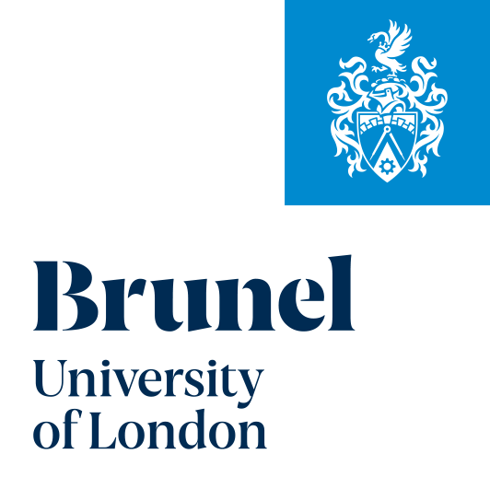

Recruitment Process for ESRC Grand Union DTP 2026/27 (Students)
- Start date will be 1st October 2026, Applications for 2026/27 will open from 1st October 2025 and will close at midday on Friday 9 January 2026.
- Initial inquiries will be directed to Emma Smith (DTP MANAGER) @ studentships@brunel.ac.uk from both pathways, Education & Health & Wellbeing.
- You will be advised of the contact details for the Pathway Lead if you wish to get more information before developing your application. Guidance and advice from potential supervisors will be available.
- You will find more information here:

https://www.brunel.ac.uk/research/Research-degrees/DTPs/Grand-Union-DTP

- Before applying, please be aware that Awards for UK/International residents cover UK tuition fees (Approx. £5006 per annum) and provide a stipend grant at the UKRI current level for 25/26 is £22780per annum . Please note that BUL will cover the difference between the international fee quoted for the relevant course for UKRI students. Please see the Terms and conditions for training funding – UKRI for further details;

- You will need to propose the academic you wish to work with as part of your application procedure. We encourage you to contact them before submitting your application to discuss your proposal. Search for research staff in your chosen field of study or. Education | Brunel University of London
College of Health, Medicine and Life Sciences | Brunel University London .
- Please see the information listed below, which will be required as part of the application to studentships@brunel.ac.uk – stating which pathway they are applying for.
  - Grand Union Health and Wellbeing Pathway at Brunel
  - Grand Union Education Pathway
    - Completed application form (see webpage as listed in point 4)
    - Completed Equal Opportunities form (see webpage in point 4)
    - An up-to-date CV
    - 2000-word proposal incl refs
    - Two academic references or the names and contact details of two academic referees. One professional reference (if applicable).
    - A copy of an undergraduate transcript, certificate, master's transcript, and certificate (if applicable). If the applicant has not yet completed a course, they should provide an up-to-date transcript.
    - A copy of an English-language qualification, where applicable. Any non-native speaker who has not been awarded a degree by a university in the UK will be expected to show English language skills to IELTS 7.0 (minimum 6.0 in any section) for the Health & wellbeing pathway and the Education pathway.
- After the deadline, applications will be sent to the GU DTP Associate Director and Brunel Pathway .
Leads. Deadline for applications: 9th January 2026 at midday .

9 You will need to apply online via the link sent to you, please keep a note of your student id number, as you will need this later on; PLEASE NOTE if you are an alumina of BUL then your application number will automatically revert to your original student id.You can track the progress of your application through the online portal;
10 NOTES: PhD applications are now processed via the online PhD application tracker, which allows potential supervisors to receive a direct link to a web page where they will be able to review all of your application documentation and record their decision. You can also select the funder, which will be ESRC for this course, under "who will pay my fees".
11 Interview Panels should include the Pathway Lead and potential supervisor. (If the supervisor is pathway lead, then an independent academic will be required). An external member of the GUDTP will be allowed as an observer. DTP Manager to take notes at all interviews; DTP Manager should complete Decision & Interview forms for all applicants, both successful and unsuccessful.
12 The DTP Manager to email all candidates with an informal outcome of the interviews in the following categories; successful – offer, unsuccessful – reject, Not successful in being awarded a scholarship, but eligible for self-funding PhD. The offer will be provisional, subject to a formal offer from the Admissions Office;
13 If successful in the interview, you will be put forward for a nomination. This may involve some revisions to your proposal. The pathway lead will complete the required DTP pathway nomination forms and forward to the DTP MANAGER 2 days before all documentation needs to be submitted to the Social Sciences Division office in Oxford, which will be by approximately around 3rd week of March.
14. A DTP Panel will then peer review each applicant to the Studentship. A panel of 10 pathway leads will meet and review the 90 applications, nomination caps to be confirmed. Each application will be reviewed independently by six academics, giving marks out of 20 as per the marking criteria. The trim mean is then taken for each application, which determines the final score. The quality threshold is 16.00 out of 20.00; those that have match funding and meet the quality threshold will receive a studentship.
- On receipt of details of successful awards from the DTP Selection Panel TO BE
COMFIRMED BY APRIL 2026, the DTP Manager will advise on next steps
- BUL to send out studentship terms and conditions offer letter to successful applicants, cc to Oxford DTP Manager ;
- Applicant returns a signed copy of the studentship letter to BUL within two weeks of the date of the letter and advises bank details to the DTP manager @ BUL. The applicant also needs to formally accept the offer of a PhD via the Admissions process;

